Kindness Calendar
Week 1: Looking After Ourselves
(How many of these challenges can you complete next week?)

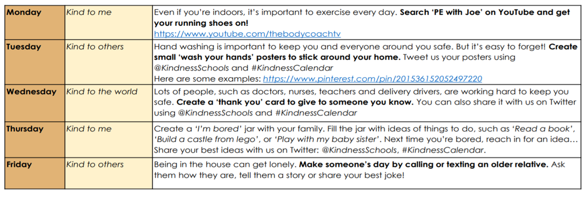

Courtesy of The Kindness School Foundation.

