Make some maps!  Make a map of the journeys you take around your area e.g. to school, to the shops or to the park. Can you include houses, shops, roads, a compass, map symbols? | Four seasons  What are the four seasons in England? What happens in each season? Which season is your favourite and why? Design a poster describing the significant changes between each season. | Rainforests  What is the same and what is different between a forest in England and a rainforest in Brazil? Which animals live there? What type of plants grow there? If you had to, which would you rather live in?
Holidays  Look through photos of places you have been in the world. Can you find these places on a map? Can you identify the country, continent and nearby seas or oceans? Where would you like to go in the future? | Geography  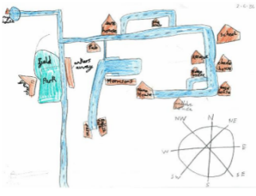  Home Learning Choices | What3words  What3words is a website/app that is used by emergency services to locate people/places when they need help. Each 3m x 3m has 3 words. Can you find the 3 words for your house, the school and a random place in the world?
United Kingdom  Look at a map of the UK. Can you name the four countries and capital cities? Select one capital city and research the human (factory, office, port, shops) and physical (mountain, coast, valley, river) geography in that area. How is it similar to Reading? | Landmarks  Randomly select a place a city from around the world on the 360cities website. Can you identify the landmarks that make that place unique? For example Paris has the Eiffel Tower, New York has the Statue of Liberty. Design a brochure for that city. | Sequencing and comparing  Can you put the world’s oceans/ continents/ countries/ rivers in order? You could use these comparison words: shortest, longest, tallest, biggest, smallest, widest, deepest etc.

