Week 7

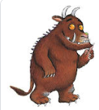

English

This is the final week of your time in Year 1 and before the Summer break and you move to Year 2. We know that it has been a very different year for you and we wanted to say a huge THANK YOU to you and your families for continuing to do amazing work and activities together at home. We are so very proud of each and every one of you.

We thought this week you could take the time to show off your amazing writing skills to your new teacher. Remember all the skills that you have learnt in Year 1: Capital letters, finger spaces and full stops! Try to see if you can use some WOW words and perhaps use conjunctions to link some sentences. We can’t wait to see your wonderful transition activities this week.

