English | MONDAY  This week, we are going to look at another hero. This tiny brave creature was very clever and saved the life of the strong, mighty whale.  What is the title of the book? Who is the author? Do you know any other books written by this author?  Here is a link to the story: Perhaps you could turn the sound down and try to read along yourself. https://www.youtube.com/watch?v=x887mPO9X9c  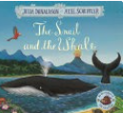  Starter: Please write the date in your book.  Monday 22nd June 2020  Please correct this sentence and write it into your book:  tHe snayl sat on a blak rok.  IALT: sequence a story. Today, we are going to enjoy the story and then you will be asked to read sentences and put them in the correct order of when they occurred in the story.  Click here for a link to the story: https://www.youtube.com/watch?v=x887mPO9X9c  What a wonderful story! We hope that you enjoyed listening and reading along.  Your task:  Task: To cut out each sentence.  - Read each sentence.  - Put them in order of when they happened in the story.  - Stick them into your book.
TUESDAY

Starter: Write the date in your book.
Tuesday 23rd June 2020
(Remember to use capital letters for days of the week and months of the year)

Please write this sentence correctly into your book:
tHe see woz as blew as the skigh

IALT: describe a character.
Today, we are going to think about how to describe the hero, the snail.

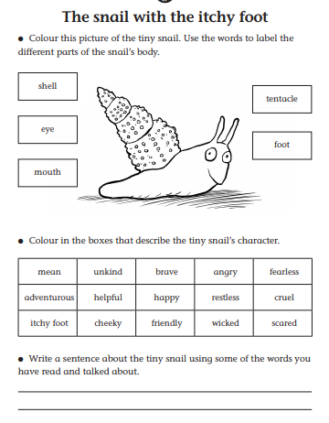

Task:
- Label the picture of the snail and colour it.
- Read the adjectives and choose ones to describe the snail.
- Write a sentence about the snail using some of these words.

WEDNESDAY
English | Today, we are going to identify rhyming words in the story.  Starter: Write the date correctly.  Wednesday 24th June 2020.  Write this sentence correctly into your books.  tHey sor golden sand and bootiful flowurs.  IALT: identify rhyming words  Today, we are going to try to identify rhyming words in the story.  Is it the first or last sound we hear in a word that we use to make rhyming pairs?  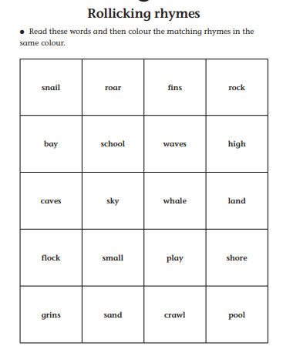:  Your task  - Read the words on the grid.  - Colour each pair of words that rhymes in a different colour.  - Add any rhyming word pairs that you can think of in your book.  Extension: Complete this rhyming activity.  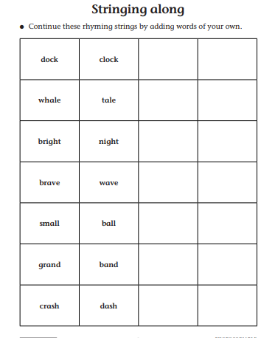

THURSDAY
Today, you are going to write a postcard from the Snail to the friends he left behind on the rock.

Starter: Write the date correctly:
Thursday 25th June 2020.
Write this sentence correctly into your book:
hE stared at the see, the skigh and the golden sand.

IALT: use adjectives to improve my sentences.
Today, you are going to pretend to be the snail who is on his big adventure. You will write a postcard to send back to your friends and you will describe what you have seen and done with the whale. You should use exciting adjectives in your sentences.

Your task:
- Address the postcard to your friend.
Dear…….
- Write a super sentence to describe something that you saw
- example: I saw colourful fish and golden sand.

- Write a super sentence about somewhere that you visited.
We saw exploding volcanoes.

- Write a super sentence about your favourite thing on the trip.
My favourite part of the adventure was seeing the towering icebergs.

- End your message.
See you soon! From your friend, The Snail.

English | FRIDAY  Each week we will continue to practise learning some words that we may like to use in our writing.  Please choose from Mild, Spicy or Hot words and write them in your book 5 times.  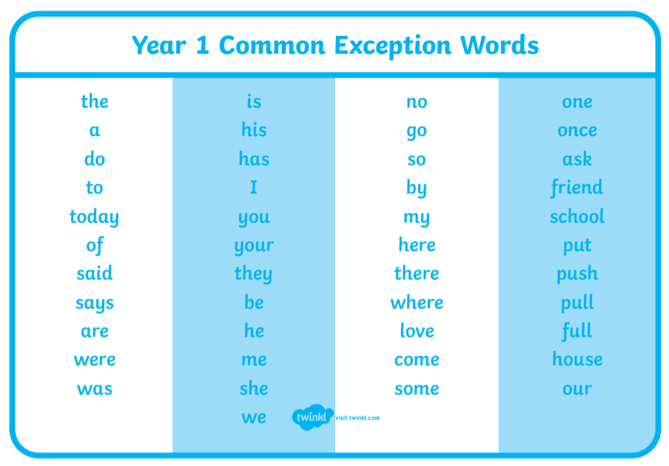  Task:  Mild: Spicy Hot  do said where  his once house  to has friend  the they come  Extension: Put each word into a sentence and write this into your book.

