Komodo dragons are cold blooded.

**WOW Write Wednesday**

**IALT: write about snapping turtles.**

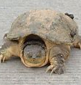   

Draw your bearded dragon. Write a sentence. Write your name

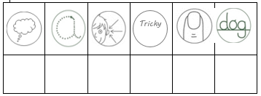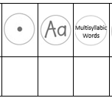Tick to self-assess.

**WOW Write Tuesday**

**IALT: write about Geckos.**

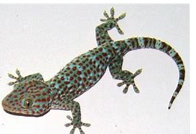   

Draw your bearded dragon. Write a sentence. Write your name.

Tick to self-assess.

**WOW Write Monday**

**IALT: write about Komodo Dragons.**

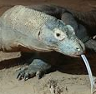   

Draw your bearded dragon. Write a sentence. Write your name

Tick to self-assess.

Read your sentence back.

Read your sentence back.

Geckos chirp to talk to each other.

Read your sentence back.

Snapping turtles live in fresh water.

.

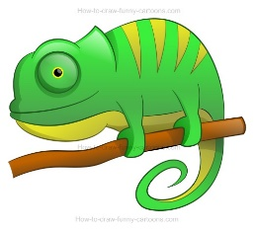

Read your sentence back.

Bearded dragons are a type of reptile.

**WOW Write Friday**

**IALT: write about bearded dragons.**

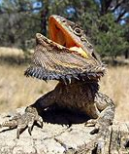   

Draw your bearded dragon. Write a sentence. Write your name

Tick to self-assess.

**WOW Thursday**

**IALT: write about chameleons.**

  

Draw your chameleon Write a sentence Write your name

Tick to self-assess.

Read your sentence back.

Chameleons change colour.

How can you make your work better?