Civitas Academy Bulletin
19/12/17

Dear Parents and Carers,

How quickly this term has gone by! It was wonderful seeing so many of you during our Christmas shows last week and the children were fantastic during our Christmas lunch last Friday too.

Farewell:

In assembly we said our farewells to Mr Wyld. I have had the privilege to work alongside Robert for the last four years and together we have strived to continuously provide exceptional opportunities for learning for all the children we serve across our three schools. We shall miss him but wish him and his family all the best for the future.

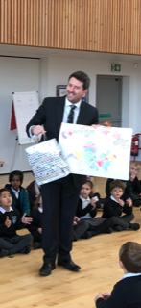

KEY STAGE 1 AWARDS:

This term we also presented our very first Key Stage 1 Awards at Civitas, it was a very proud moment!

AWARD | KS1
 | Name | Class
MATHS | Aryan | Matilda
LITERACY | Zara | Gruffalo
SCIENCE | Supreeth | Pinocchio
HUMANITIES | Siddharth | Pinocchio
ART | Akshitha | BFG
RESILIENCE | Davidas | Gruffalo
COMMUNICATION | Jude | Gruffalo
KINDNESS | Shayla | Matilda
ATTENDANCE | Ariyah | Matilda
RIGHTS RESPECTING | John-Macaulay | BFG
LEADERSHIP | Toni-Ann | Pinocchio
COMMITMENT TO EXCELLENCE | Winefred | BFG

Stars of the Week

Gruffalo – Angelina – for her super performance
Pinocchio – Musa – for making great progress in his reading
Matilda – Luca – for great improvement with his learning behaviours
BFG – Temi – for good phonics

Attendance:

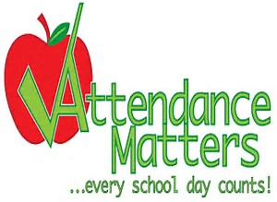

Our School Target for this year is 96.5%

Congratulations to BFG class this week with a great 98.18% attendance.

Across the school we are all working hard to make improvements with our attendance. Our Whole school attendance this week was 93.65%, we need to improve upon this quickly.

BFG – 98.18%
Matilda – 97.73%
Gruffalo – 93.21%
Pinocchio – 93.46%
Elmer – 88.62%
Paddington – 92.71%

Key Dates:

Wednesday 3rd January 2018 – INSET DAY (School CLOSED to pupils)

Thursday 4th January 2018 – Pupils return to school (Breakfast and After school club begins)

Have a wonderful break and a fantastic new year,

Salima Ducker

Executive Head Teacher

School contact details:
Address – 90a Great Knollys Street
Reading
RG1 7HK
Tel: 0118 467 6720
Email: office@civitasacademy.co.uk
Web: www.civitasacademy.co.uk (currently under construction)
Twitter: @R2Civitas
Facebook: Civitas Academy
After School Club Tel: 07519938866

