Lifecycle of a Butterfly

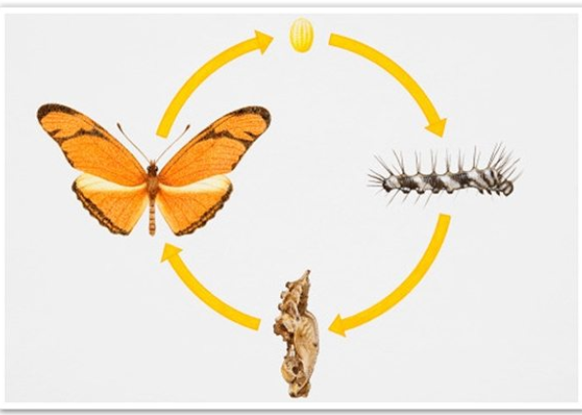

Hello Year 1,

During the Easter holiday’s our beautiful butterflies hatched from their cocoons (Pupa)! Mrs Aram and Mrs Carey gave the butterflies some oranges and they loved it because they were sweet and juicy! They were very noisy at night time, but it was lovely to see them grow!
We made a video of the butterflies being released into the garden; this is on our Youtube channel.

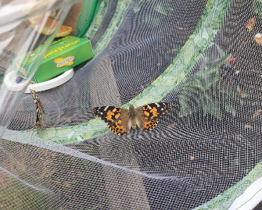
Write the date in your Home Learning Book and try to answer the following questions:

- What is another word for a cocoon?

- Describe what you see in the video?

- What colours were the butterflies?

- Draw a picture of a butterfly and label it.

Challenge: What else might the butterflies like to eat?

Vocabulary to help you:
Caterpillar chrysalis butterfly

Cocoon change life cycle

Enjoy this information about the lifecycle of a butterfly:
https://www.natgeokids.com/uk/discover/animals/insects/butterfly-life-cycle/

