Monday
English | Starter: Get a parent, sibling or family member to test you on your spellings:  immature, immobile, impossible, impatient, impolite, illegal, illiterate, illegible, illogical, illuminate  IALT: check and change spellings accurately.  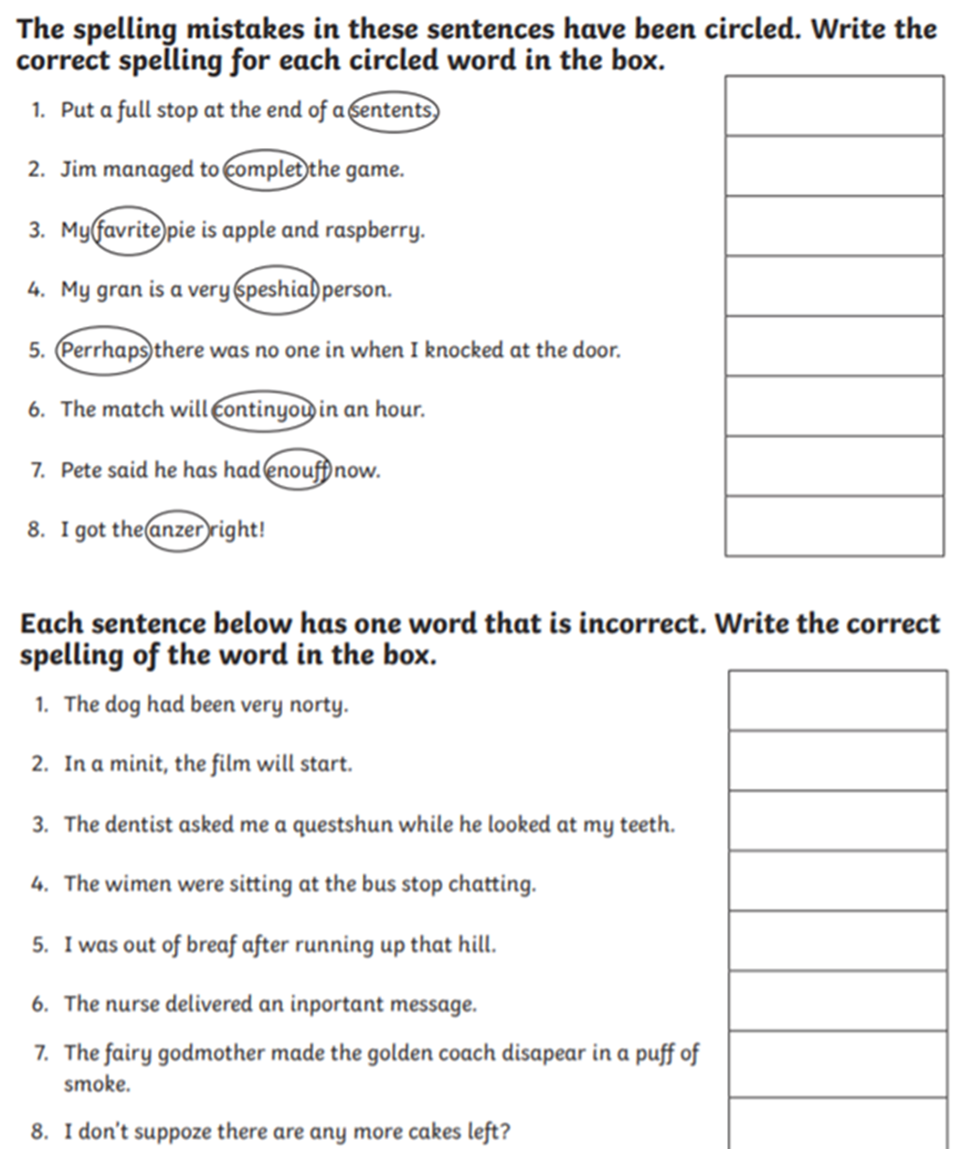
Maths | IALT: add fractions.  Please follow the link below and click on “Summer Term - Week 2 (w/c 27th April)”  https://whiterosemaths.com/homelearning/year-3/  Lesson 1: add fractions  Please watch the video which links to lesson 1 on adding fractions.  Once you have watched that there are 7 questions and answers. Please click on the questions first and complete in books, encourage your child to then mark their answers with a different coloured pen. Alternatively, you can send it to me to mark.
Guided Reading | 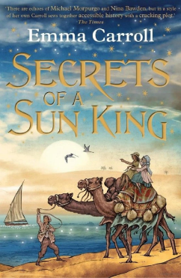  Vocab lesson: Chapter 4  Curse – a supernatural power to meant to cause harm or punish someone or something.  Reassure- the action of removing someone's doubts or fears  Shudder- to tremble, typically because of fear.  Procession- a procession of vehicles or people travelling to or from a funeral.  unknown solider- an unidentified representative member of a country's armed forces killed in war, given burial with special honours in a national memorial.  Remember to Spell the words, draw, define and use in a sentence
Science | Choose one of your Science activities.

Tuesday
English | IALT: describe a scene.  Watch the YouTube clip: https://www.youtube.com/watch?v=8Tc7PMuHTJQ  Watch it again and pause at 4.05.  We will be writing a setting description about what is happening to the artist. How would he be feeling as he approaches the Pharaoh?  Think about:  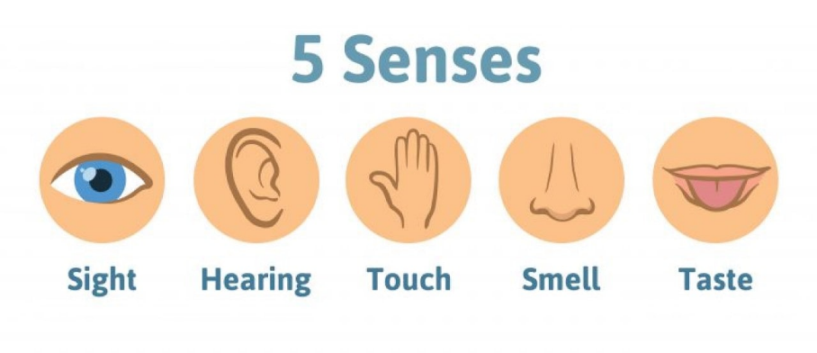  My example:  My knees were shaking as I approached the Pharaoh. Darkness fell upon me whilst I walked down the long carpet towards her. It was the colour of blood. A piercing roar filled the air and I felt as though my ear drums would burst. My hands were sweating and my ears were ringing. In my hands, I clutched my art work. Would it be good enough? Would she like it? Or would this be for me, like for so many others, the end...?  You try! Write a description about the artist approaching the Pharoah. Think about how nervous he must feel!  Include: Pronoun ‘I’ (first person), adjectives, senses, fronted adverbials.
Maths | IALT: subtract fractions.  Please follow the link below and click on “Summer Term - Week 2 (w/c 27th April)”  https://whiterosemaths.com/homelearning/year-3/  Lesson 2: subtract fractions  Please watch the video which links to lesson 2 on subtracting fractions.  Once you have watched that there are 8 questions and answers. Please click on the questions first and complete in books, encourage your child to then mark their answers with a different coloured pen. Alternatively, you can send it to me to mark.
Guided Reading | Watch Miss Parry read Chapter Four of “Secrets of the Sun King”  https://www.youtube.com/watch?v=7zodvFGYkaU  Recall and retrieval questions.  Where is Lil now?  What is so special about the jar?  What does Lil now have to do with the jar?  Who was the Unknown soldier?  Why did Dad not wait for Granddad when they were watching the procession?  Remember to answer the questions in full sentences.
Geography | Choose one of your Geography activities.

Wednesday
English | IALT: plan my writing.  Tomorrow we will be writing a letter from Cleopatra the Pharoah to the artist.  Today we will be gathering ideas for key vocabulary we can use in our letter.  Think about:  Why are you writing to him? What is the purpose of your letter?  What did other paintings of your look like? How could you compare them – what vocabulary will you use? What was the artist’s painting like?  What will you do to say thank you to him?  Who is it to/from?  Plan your letter from the Cleopatra to the Artist.  Here is an example of my planning:  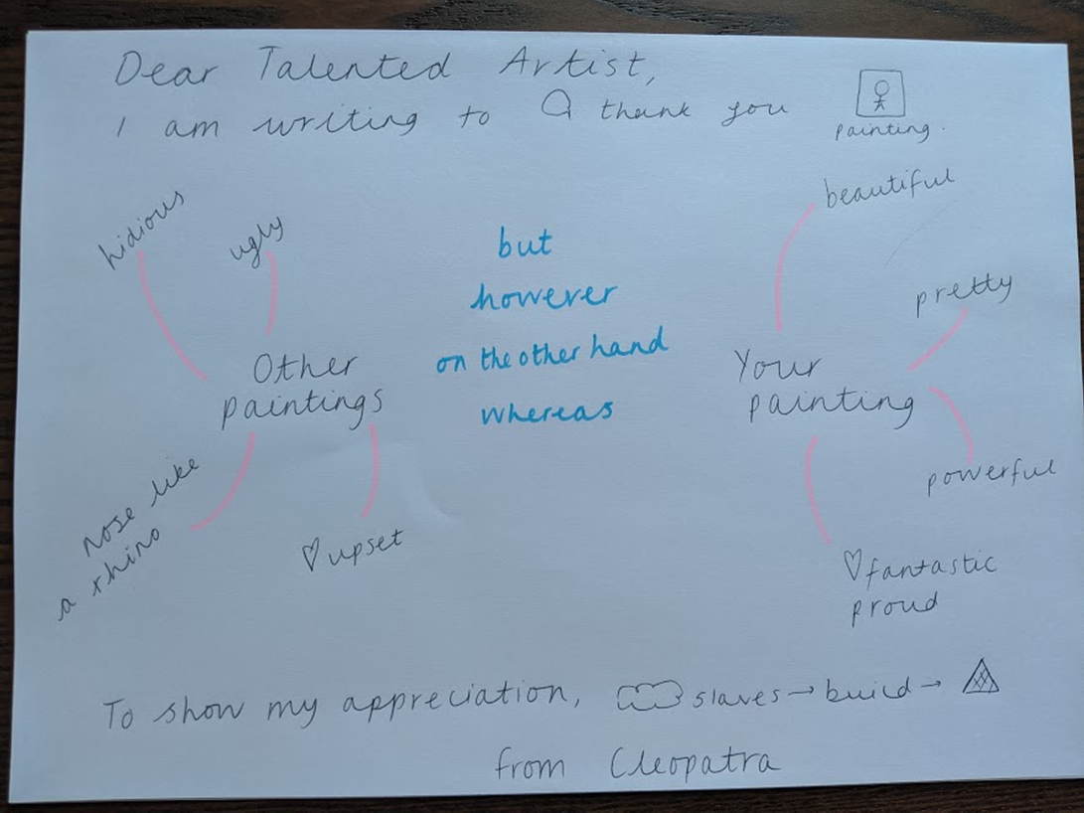
Maths | IALT: use my problem solving skills.  Please follow the link below and click on “Summer Term - Week 2 (w/c 27th April)”  https://whiterosemaths.com/homelearning/year-3/  Lesson 3: problem solving  Please watch the video which links to lesson 3 on problem solving.  Once you have watched that there are 4 questions and answers. Please click on the questions first and complete in books, encourage your child to then mark their answers with a different coloured pen. Alternatively, you can send it to me to mark.
Guided Reading | Watch Miss Parry read Chapter Four of “Secrets of the Sun King”  https://www.youtube.com/watch?v=7zodvFGYkaU  Questions on Inference Summary:  Why is Lil so shocked when your grandad is cough?  Is Lil happy to be going to Egypt?  Why is the burial of the Unknown soldier so important?  Why is there an unknown soldier in all countries in the War? What does it represent?  Remember to answer the questions in full sentences.
PSHE | Choose one of your PSHE activities.

Thursday
English | IALT: write a letter.  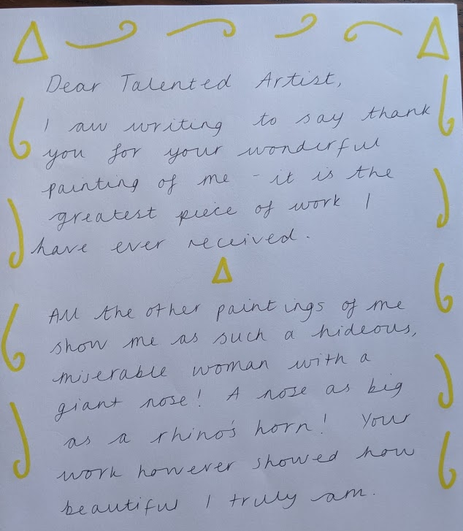  Think about what the PURPOSE of the letter is again- to thank the artist and make sure he knows how happy you are with his artwork! Use your plans from yesterday to help you write your letter. Here is an example of my first 2 paragraphs:  Can you include:  Paragraphs conjunctions contrasting words (but, however, on the other hand)  expanded noun phrases similes  You could also take a photo and email your work to your teacher – we love seeing what you have been up to!
Maths | IALT: use my problem solving skills.  Please follow the link below and click on “Summer Term - Week 2 (w/c 27th April)”  https://whiterosemaths.com/homelearning/year-3/  Lesson 4: problem solving  Please watch the video which links to lesson 4 on problem solving.  Once you have watched that there are 4 questions and answers. Please click on the questions first and complete in books, encourage your child to then mark their answers with a different coloured pen. Alternatively, you can send it to me to mark.
Guided Reading | Task:  Draw and design a medal to give to the unknown soldier. Would it have words on it such as courage? Or Brave? Would it have a picture of a solider on it?
History | Choose one of your History activities.

Friday
English | Task: Practise the following spellings – use a method that suits you. You will be tested on these on Monday 15th June.  iron  ironic  irritate  irregular  irrelevant  irresponsible  irresistible  irrational  irreplaceable  irresolvable
Maths | IALT: reflect on previous Mathematics learning and challenge myself.  Friday Maths challenge:  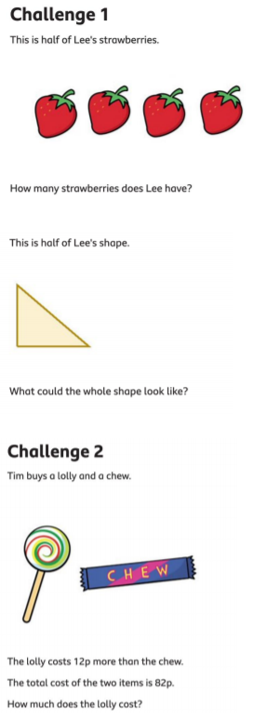  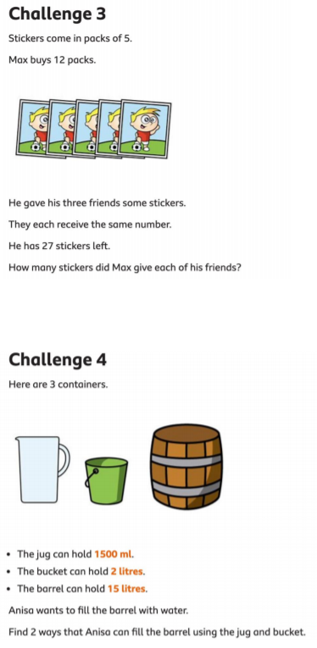  ANSWERS:  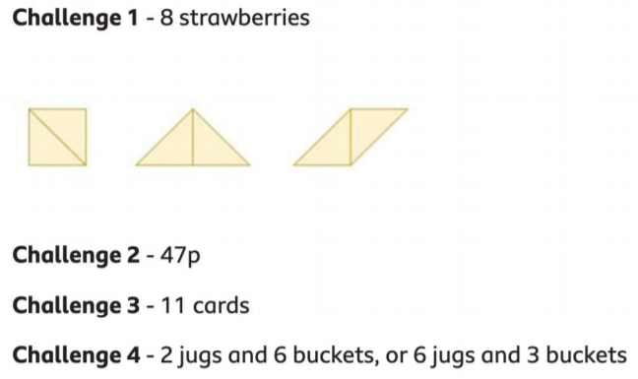
Guided Reading | Accelerated reader – complete a quiz online. Many books you have at home will also be on accelerated reader, search the name to find out if you can do a quiz about one of your own books.  Steps: School website – class pages – Accelerated reader – log in – Accelerated reader
Art | Choose one of your Art activities.

