Monday
English | 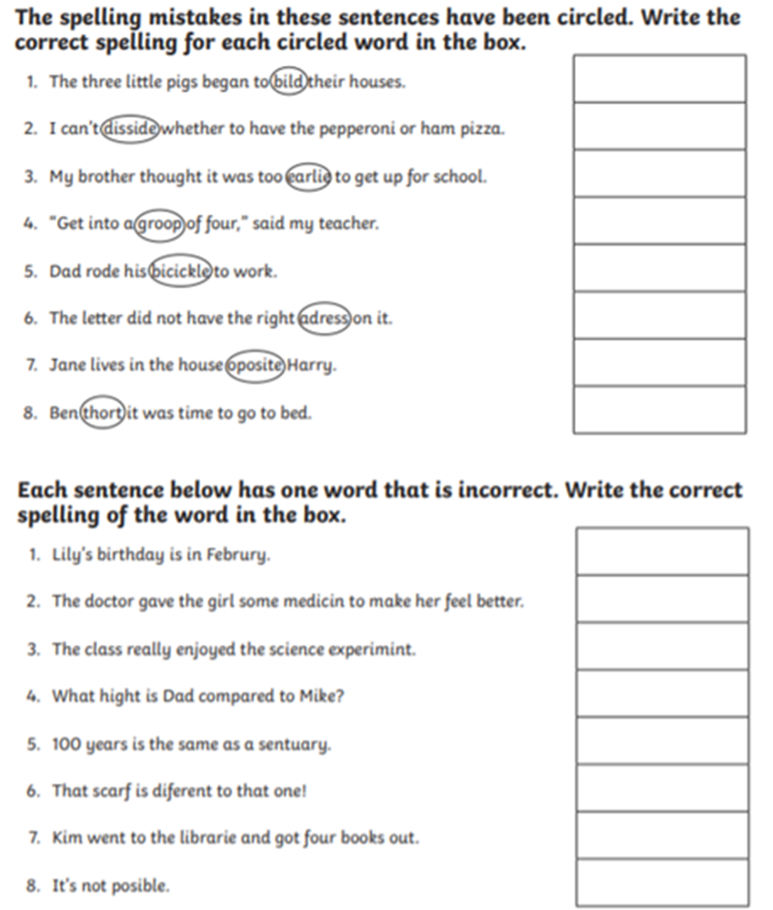  IALT: check and change spellings accurately.
Maths | IALT: find equivalent fractions.  Please follow the link below and click on “Summer Term - Week 1 (w/c 20th April)”  https://whiterosemaths.com/homelearning/year-3/  Lesson 1: equivalent fractions  Please watch the video which links to lesson 1 on equivalent fractions.  Once you have watched that there are 5 questions and answers. Please click on the questions first and complete in books, encourage your child to then mark their answers with a different coloured pen. Alternatively, you can send it to me to mark.
Guided Reading | 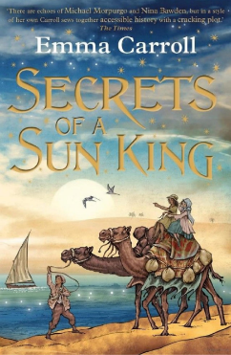  Vocab Lesson: Chapter Three  “carbolic” – disinfectant soap containing phenol  “waiting to peach on you” - waiting to tell on you  “thruppence” - The British threepence coin, usually simply known as a threepence, thruppence, or thruppenny bit, was a unit of currency equalling one eightieth of a pound sterling, or three old pence sterling.  “infuriating” - making one extremely angry and impatient.  “airs and graces” - false ways of behaving that are intended to make other people feel that you are important and belong to a high social class.  Remember to Spell the words, draw, define and use in a sentence
Science | Choose one of your Science activities.

Tuesday
English | IALT: describe a character.  Watch the clip https://www.youtube.com/watch?v=c0yxXmE6w_4  It is all about a young pharaoh finding the decisions she has to make very difficult. Our longer piece of writing on Friday will be about this clip.  Activity: Write a character description about her- two paragraphs long.  The first paragraph could be about her PHYSICAL character traits- what she looks like.  The second paragraph should be about her INTERNAL character traits- her personality.  Think about including your own ideas- why is she a pharaoh when she is so young? How does she feel about what happens to the man? How does she feel about her father?  Can you include: adjectives adverbs fronted adverbials
Maths | IALT: find equivalent fractions.  Please follow the link below and click on “Summer Term - Week 1 (w/c 20th April)”  https://whiterosemaths.com/homelearning/year-3/  Lesson 2: equivalent fractions  Please watch the video which links to lesson 2 on equivalent fractions.  Once you have watched that there are 6 questions and answers. Please click on the questions first and complete in books, encourage your child to then mark their answers with a different coloured pen. Alternatively, you can send it to me to mark.
Guided Reading | Watch Miss Parry read Chapter Three of “Secrets of the Sun King”  https://youtu.be/e712zJSs6AU  Recall and retrieval questions.  - Why won’t the nurse let Lil in to see her Grandad?  - What did Lil spend her last thurrpance on?  - What does Lil find in the Egyptian room?  - What are the names of the children she finds in the Egyptian room?  - Who found the artefact in the Egyptian room?  Remember to answer the questions in full sentences.
Geography | Choose one of your Geography activities.

Wednesday
English | IALT: plan my writing.  Watch the clip from yesterday again: https://www.youtube.com/watch?v=c0yxXmE6w_4  Tomorrow, we will be writing a job advert for a new Pharoah! So today we will plan and we need to think about what jobs the Pharoahs had to do.  - Look after their people.  - Make laws.  - Defend Egypt from any enemies.  - Be the high priest and communicate with the Gods and Goddesses.  Create a mind map of each of these 4 things. What QUALITIES will a Pharoah need to have to be able to do them?  Example:  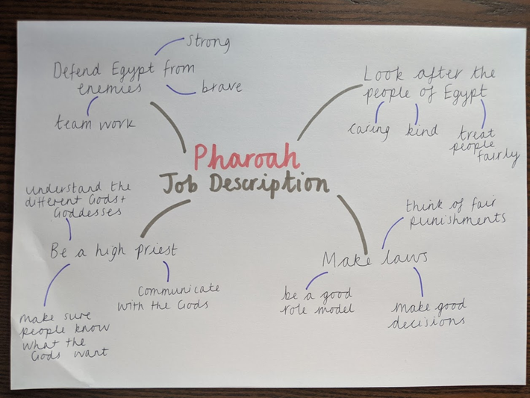  This will be our plan that will help us write our advert for tomorrow.
Maths | IALT: compare fractions.  Please follow the link below and click on “Summer Term - Week 1 (w/c 20th April)”  https://whiterosemaths.com/homelearning/year-3/  Lesson 3: compare fractions  Please watch the video which links to lesson 3 on compare fractions.  Once you have watched that there are 7 questions and answers. Please click on the questions first and complete in books, encourage your child to then mark their answers with a different coloured pen. Alternatively, you can send it to me to mark.
Guided Reading | Answer Questions on Chapter Three of the Secrets of a Sun King.  If you need to watch the clip again that’s ok!  https://youtu.be/e712zJSs6AU  Questions on Inference Summary.  - Why is it important when Lily found out the artefact was found by Professor Hanawati?  - Why does she find Tulip and Oz so interesting?  - Why was Lily socked when the woman walked in and she found out it was Tulips and Oz’s Mother?  - Why is Lily panicking when she finds that Tulip has taken her bag?  - What is Lily’s plan to find that bag?  Remember to answer the questions in Full sentences.
PSHE | Choose one of your PSHE activities.

Thursday
English | IALT: write a persuasive advert.  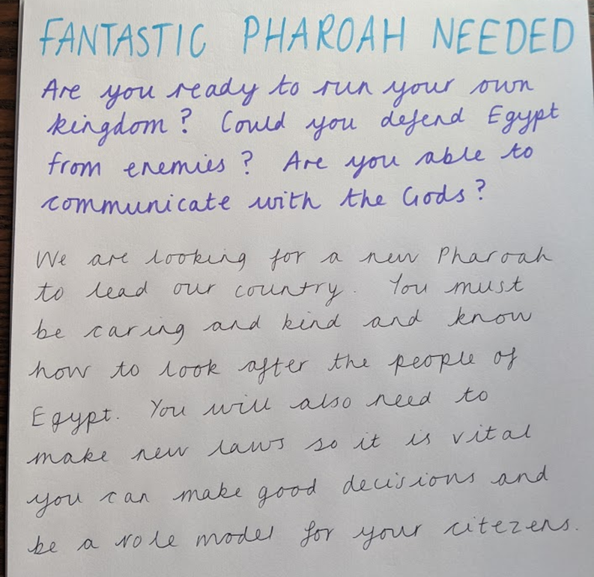  Imagine you are trying to hire a new Pharoah for Egypt. Use your planning ideas from yesterday to create an advert for the job. Here is my example:  Activity: Write an advert for a new Pharoah.  Try to include: Rhetorical questions Adjectives +er and +est suffix endings  Extension: draw a picture and decorate the border to make your advert eye-catching!
Maths | IALT: order fractions.  Please follow the link below and click on “Summer Term - Week 1 (w/c 20th April)”  https://whiterosemaths.com/homelearning/year-3/  Lesson 4: order fractions  Please watch the video which links to lesson 4 on order fractions.  Once you have watched that there are 7 questions and answers. Please click on the questions first and complete in books, encourage your child to then mark their answers with a different coloured pen. Alternatively, you can send it to me to mark.
Guided Reading | When Oz is in the Egyptian room, it says that he is learning hieroglyphics. Can you write a sentence using hieroglyphics that Oz could read when we get back to school? Here are some examples of some hieroglyphics:  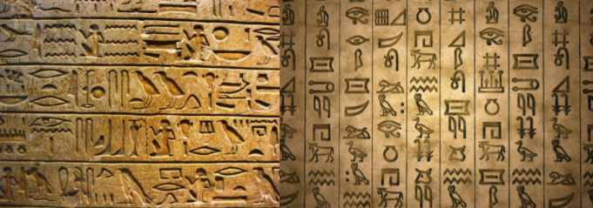  Here is what you can use to help you create a sentence:  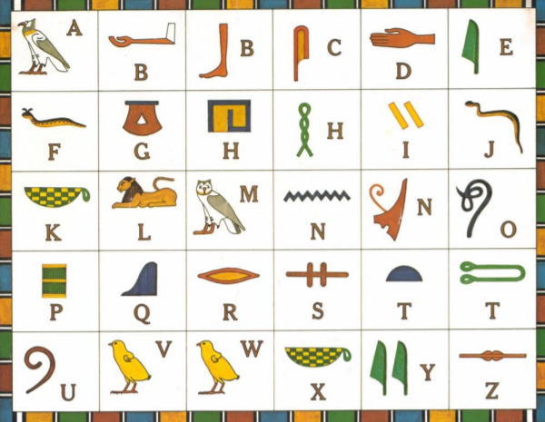
History | Choose one of your History activities.

Friday
English | IALT: use the il- and im- prefix.  You will be tested on your spellings on Monday 8th June. Use this lesson to refresh your understanding of the il- and im- prefixes and practise your spellings once more.  Task: Can you create golden rules about the prefixes im- and il-. What do you notice about the words? Are there any patterns within the root words? Create one gold rule for each prefix.  Practise the following spellings – use a method that suits you. Can you highlight where the in- prefix are?  immature  immobile  impossible  impatient  impolite  illegal  illiterate  illegible  illogical  illuminate
Maths | IALT: reflect on previous Mathematics learning and challenge myself.  Friday Maths challenge:  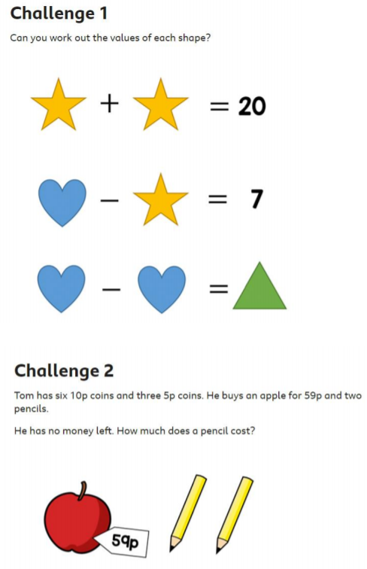  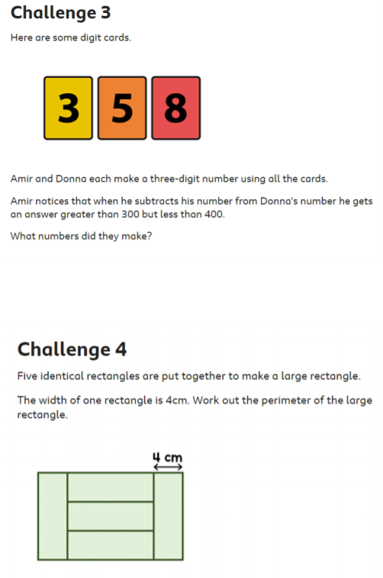  ANSWERS:  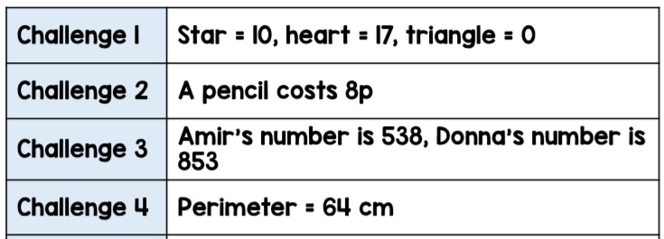
Guided Reading | Predictions:  Knowing how Chapter three ends, what do you think might happen next? Create some predictions about what you think will happen next and why!  Also, if you have made your own hieroglyphics, why not send a picture of yourself and the sentences you’ve created to your teacher? We would love to see your sentences! We can put then up on our “WOW WALL”!  Accelerated reader – complete a quiz online. Many books you have at home will also be on accelerated reader, search the name to find out if you can do a quiz about one of your own books.  Steps: School website – class pages – Accelerated reader – log in – Accelerated reader
Art | Choose one of your Art activities.

