Monday
English | Starter: Get a parent, sibling or family member to test you on your spellings:  incorrect, inactive, incredible, inaccurate, indirect, independent, inconsiderate, inability, invisible, insecure  Well done, we are almost finished our first Summer term and you’ve done this all at home!  Now we will recap over the techniques we have learn throughout Summer Term 1 and be quizzed on them. Firstly, can you list and define all the techniques we have used over this term and how they affect our writing:  Similes: What do they do? Why are they useful? Can you use one in a sentence?  Using er and est suffixes: What do they do? How are they useful? Use them in a sentence.  Fronted adverbials: What do they do? Why are they useful? Can you use one in a sentence?  Inverted commas: What do they do? Why are they useful? Can you use one in a sentence?  Now go and do a Kahoots quiz on our techniques, please use your real name when entering the Quiz so your teachers can see what score you get!  Try your best and good luck 😊
Maths | IALT: Master using addition with fractions  Watch this clip: https://www.youtube.com/watch?v=z1JbMIR3TJQ  Challenge: pause the video and work out some of his examples  Mild- I can add simple fractions with help from a bar model  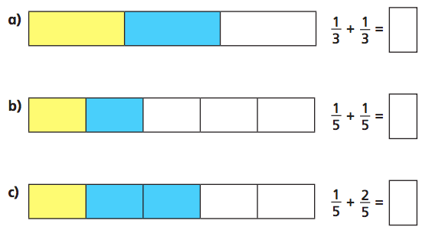  Spicy- I can apply my knowledge to represent this on my own bar model  hhh- I can demonstrate my knowledge of adding fractions to explain my answers when solving problems  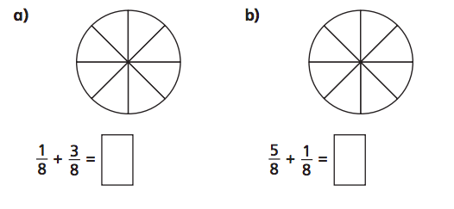  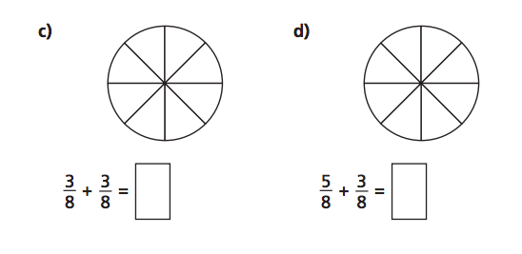
Guided Reading | 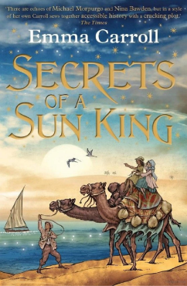  Let’s start our vocab lesson - remember to set it out like you did last week.  Draw – Define – Use.  “clutching” - to grab or grasp.  “coincidences” - events or circumstances that have no apparent causal connection with one another.  “dwell” - keep thinking about one thing.  “Hieroglyphics" - ancient Egyptian writing.  “Malaria” - disease that is passed on by a mosquito.
Topic | In Geography IALT: describe key aspects of the river Nile  Task: Make a fact file about the river Nile. You can design your fact file as creatively as you would like as long as it includes at least 10 facts and some drawings or photographs.  Your fact file could include the answers to some of these questions:  - How long is the river Nile?  - Where does it start and end?  - What are the two main tributaries (smaller rivers or streams that come together to form a larger river or lake) of the river Nile?  - What animals and wildlife live in the river Nile and its banks?  - Why did the river Nile flood every year?  - Why does the river Nile no longer flood?  Here is an example of a fact file without any information:  Challenge: Research what type of plants grow around the river Nile. Find out what these plants are used for. Present your findings on a poster that includes drawings.  Useful links:  https://www.natgeokids.com/uk/discover/geography/physical-geography/nile-river-facts/  https://www.scienceforkidsclub.com/nile-river.html  https://www.historyforkids.net/river-nile.html  https://www.sciencekids.co.nz/sciencefacts/earth/nileriver.html  https://www.britannica.com/list/11-fascinating-nile-river-plants-and-animals

Tuesday
English | Starter: Why would I use inverted commas in a newspaper report?  IALT: Gather information to create a fact file.  Over the last 6 weeks we have gathered, created and investigated so much about the Ancient Egyptians. We have got information in our Topic, English and Guided reading.  Now we can create a fact file of everything we have done so far in this topic to show our knowledge.  Task: Gather information about the Ancient Egyptians.  Go through your book and bullet point all the interesting facts you have found out about the Egyptians. Think about:  - The life they had in Egypt and how it was different to ours.  - What Gods did they believe in?  - How were the Ancient Egyptians different to us?  - How did they treat their dead?  - What was “mummification”?  - Why where the Pyramids so important?  These are all things you can think about when collecting your information.  Draw some pictures also and maybe talk about why they wore the clothes they did. Was it hot or cold in Egypt?  Here are some links to gather more information:  https://www.historyforkids.net/ancient-egypt.html/  http://www.primaryhomeworkhelp.co.uk/egypt/general.htm  https://www.youtube.com/watch?v=T7WhIybg_Qo  https://www.youtube.com/watch?v=lZOPWSXMvzI
Maths | IALT: Apply my knowledge of addition of fractions to real life scenarios  Part-whole models are used to display how the two bottom parts interact to create the number (or fraction) on top.  The two bottom fractions should be added to create the top number.  For instance:  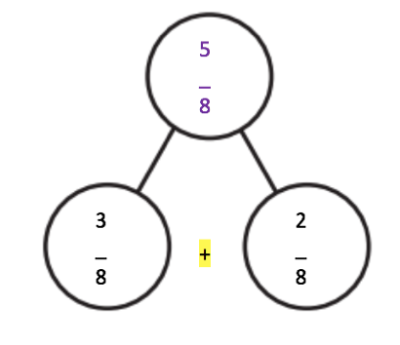  3 2 5  _ + _ = _  8 8 8  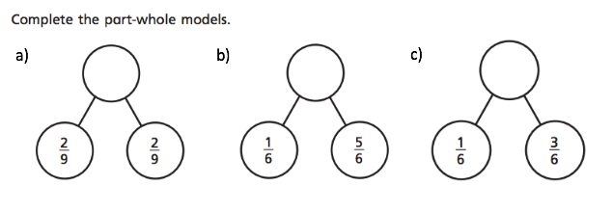  Mild- I can show addition of fractions using a part- whole model  Challenge: Which part- whole model is the odd one out? Why?  Spicy- I can apply my knowledge of adding fractions to solve real life problems  Answer this question and show your working out:  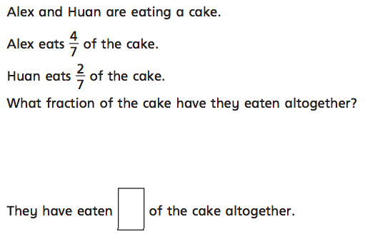  hhh- I can demonstrate my knowledge of adding fractions to explain my answers when solving problems  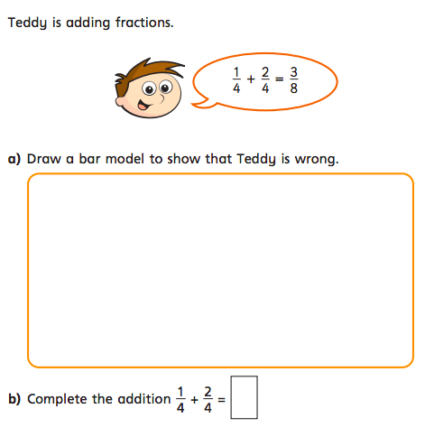
Guided Reading | Watch Miss Parry read Chapter Two of “Secrets of the Sun King” https://youtu.be/TeYROn2UdPw  Recall and retrieval questions. Answer in full sentences.  1. When Lily got home what was Dad arguing with?  2. What was in the box that Lily opened?  3. Could Lily open the jar she had found?  4. What is wrong with Grandad’s lungs? What caused Grandad to become ill?  5. Does Lily start to become scared of the jar when she falls asleep?  6. Explain your answer. Remember to answer the questions in full sentences.
Topic | In Geography IALT: recognise how the river Nile continues to help people to survive.  Watch this video about how the river Nile helps people survive in Egypt: https://www.bbc.co.uk/bitesize/clips/z3rwmp3  Task: Make a mind map of ways the river Nile helps people to survive in dry land.  Key questions:  - Why was the river Nile so important to the ancient Egyptians?  - Why did they rely on it to survive?  - Is it still important to Egyptians today?  - How many different ways is the river used? (food, leisure, drinking and more)  Use the information given to you from the video as well as information you have found from your own research.  Challenge: Research the Wafaa al-Nil festival. Find out when and why the festival is celebrated each year. Write down any information you find out.  Useful links:  https://www.natgeokids.com/uk/discover/geography/physical-geography/nile-river-facts/  https://www.scienceforkidsclub.com/nile-river.html  https://www.historyforkids.net/river-nile.html  https://www.sciencekids.co.nz/sciencefacts/earth/nileriver.html

Wednesday
English | IALT: Draft my fact file.  Watch Miss Parry’s video on drafting a fact file.  Task: create your headings for your information.  Your headings could be:  What did the Ancient Egyptians believe in?  What did the Ancient Egyptians wear?  What did the Ancient Egyptians ritual for the dead?  What did the Ancient Egyptians worship?  How did the Ancient Egyptians treat their Pharaohs?  This about what pictures to use and draw. How might we lay this out?
Maths | IALT subtract fractions  Watch this YouTube video https://www.youtube.com/watch?v=c5dNa2TVHiQ  M- I can show how I subtract fractions  S- I can apply my knowledge of how to subtract fractions to solve problems  Answer this question:  Hhh- I can use my knowledge of subtracting fractions to explain my answers when solving problems.
Guided Reading | Answer Questions on Chapter Two of the Secrets of a Sun King.  If you need to watch the clip again that’s ok! https://youtu.be/TeYROn2UdPw  Questions on Inference Summary.  1. Why does Lily have an urge to open the box even though it is addressed to her Grandad?  2. How can she tell that this jar is special?  3. Why is Lily so shocked when she finds out that her Grandad had had Malaria?  4. Is Malaria something you can get in England?  5. Why doesn’t Mum want Lily to visit her Grandad in Hospital? What does this make Lily do?  Remember to answer the questions in full sentences.
Topic | IALT: annotate a setting description.  Please visit our YouTube page to watch clip to support this lesson.  Task:  m- I can identify literary devices of a setting description.  Annotate the setting description below identifying the following literary devices: expanded noun phrases, the past tense, fronted adverbials, and simple, complex, and compound sentences.  As I sat in my boat watching the sunrise, I could hear the sound of the birds chirping cheerfully in the open fields. The beautiful river glistened in the sunlight like a million diamonds. The air was hot; I could feel the sun beaming down on my skin. Although fast flowing, the river looked inviting, with water that felt as cold as ice. Wet, reedy grass spread along the vast river bank for miles. I could smell the fresh, sharp aroma of the grassy verges. I noticed a crocodile lying on the edge of the riverbank, motionless, awaiting its prey. I looked into the water, it was cloudy. As quick as a flash, a shoal of fish jumped gracefully out of the water. I was shocked. The fish were fascinating, their scales shimmered reflecting the light from the sun. It was an extraordinary sight.  s- I can explain the purpose of using literary devices in descriptive writing.  Write down why you think each literary device is used? What is its purpose?  For example:  The purpose of describing the five senses in a setting description is that it creates atmosphere, it allows the reader to experience what it is truly like to be in that place.  hhh- I can prioritise literary devices.  What do you think is the most important literary device used in this setting description? Have a go at ranking them from most important to least important.  Challenge: What are the five senses? Can you identify if any of them were used in the setting description?

Thursday
English | IALT: edit and publish my fact file  Task: Go back to your fact file information from yesterday and read it thoroughly – It’s a good idea to read aloud to someone or to yourself so you can hear what you have written.  Can you notice any mistakes you made? Use a purple pen to edit.  - Use a dictionary or the internet to help you correct any spelling mistakes you have made.  - Check you have use correct punctuation.  Once you have edited with a different colour pen, you can publish your fact file! Use a new page in your book or a piece of paper.  Set your fact file so there are different paragraphs set in different places.  Extension: Send a pictures of your fact file to your teachers.
Maths | IALT apply my knowledge of subtracting fractions to solve problems  M- I can show how I solve problems of subtracting fractions  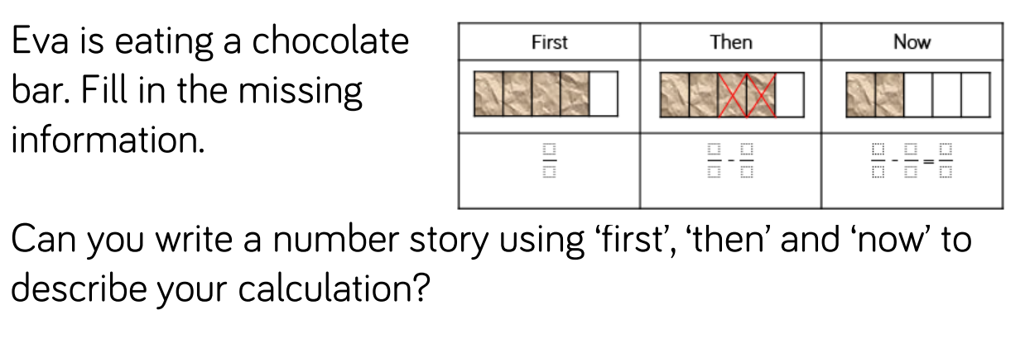  S- I can apply my knowledge of adding and subtracting fractions to solve problems  Hhh- I can use my knowledge of subtracting fractions to explain and justify my answers when solving problems.  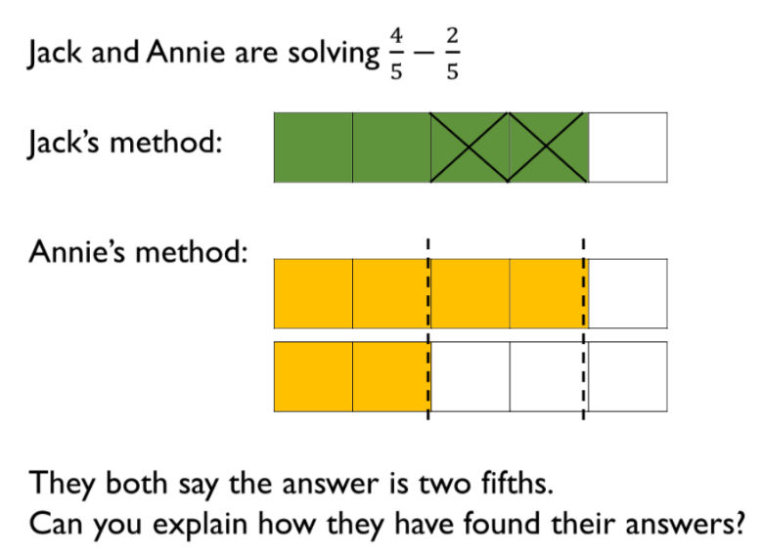
Guided Reading | For your task this week you are going to draw and label the special jar that Lily found. Go back over the video if you need to what recap what the jar looked like and the detail around it.  Here are some pictures of the jar:  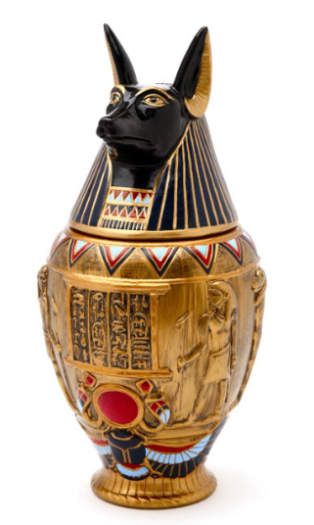  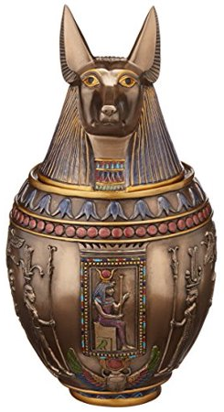  Can you label it?  Why does it have a dog's head on that top?  What does Anubis represent?
PE | See separate guidance on PE activities.

Friday
English | IALT: use the il- and im- prefix.  Stater:  What is a prefix? Write a definition of what prefixes are.  What do you think the im- and il- prefix meaning are?  Both im- and il- prefixes mean: not or the opposite of.  Task: Can you create golden rules about the prefixes im- and il-. What do you notice about the words? Are there any patterns within the root words? Create one gold rule for each prefix.  Practise the following spellings – use a method that suits you. Can you highlight where the in- prefix are?  immature  immobile  impossible  impatient  impolite  illegal  illiterate  illegible  illogical  illuminate
Maths | IALT: reflect on my learning of fractions.  Please use this session to catch up on any learning you may have missed or would like more time to explore. Alternatively, you can use this time to do extra mathematics – please see our useful website section on the school website to find Mathematics resources.
Guided Reading | Predictions: Knowing how Chapter two ends, what do you think might happen next? Create some predictions about what you think will happen next and why!  Also, if you created a jar yesterday, why not send a picture of yourself and the jar you’ve created to your teacher? We would love to see your jars! We can put then up on our “WOW WALL”!  Accelerated reader – complete a quiz online. Many books you have at home will also be on accelerated reader, search the name to find out if you can do a quiz about one of your own books.  Steps: School website – class pages – Accelerated reader – log in – Accelerated reader
Topic | IALT: write a setting description about the river Nile.  Please visit our YouTube page to watch clip to support this lesson.  Task 1: Draw a picture of a setting on the river Nile. You will use this picture to inspire your own setting description, make it as colourful and busy as you want. Think about what you have learned about the river Nile over the past few days. What animals live there? What is the weather like?  Challenge: When you are drawing your picture think about any adjectives you could use to describe the setting. If you have any idea write them down, it will help you later.  Task 2: Using your picture as inspiration write your own setting description.  m- I can write a setting description using the past tense.  s- I can write a setting description including fronted adverbials and expanded noun phrases.  Include:  Expanded noun phrases  The past tense  Simple, complex and compound sentences  Fronted adverbials  Describe the five senses (see, hear, touch, taste, smell)  hhh- I can write a setting description using the five senses to create atmosphere.

