Monday
English | We are going to be using our persuasive skills in English this week. You will be creating an advert to persuade Egyptian pharaohs that your pyramid is the best for them to be buried in!  Starter: Get a parent, sibling or family member to test you on your spellings:  dropped, biggest, wedding, goddess, flattest, eggshell, current, common, command, button  IALT: use +er and +est suffixes.  Task: Create tables in your books like the ones below and change the words so that they need with +er and then +est.  Root word Add ‘er’ Add ‘est’  Tall Taller Tallest  Short  Cold  Quick  Slow  Smart  Rich  Can you notice a pattern when you have to change words which either end with an ‘e’ or ‘y’? Below each table can you explain the rule. I have completed the first word  Words ending in ‘e’ Add ‘er’ Add ‘est’  Nice Nicer Nicest  Late  Close  Ripe  Brave  What is the rule? _______________________________________  Words ending in ‘y’ Add ‘er’ Add ‘est’  Happy Happier Happiest  Pretty  Funny  Lucky  Chilly  What is the rule? ________________________________________  Extension: What +er and +est words do you think you would use in your advert? Make a list of useful words to use later on in the week.
Maths | IALT: explore fractions.  Please refer to the school YouTube channel for the teacher input. This unit can be quite challenging for children so it is very important that if they do not grasp a concept or cannot answer a question, please email the year group email so that we can address any concerns.  Mild- I can identify and describe what fractions are.  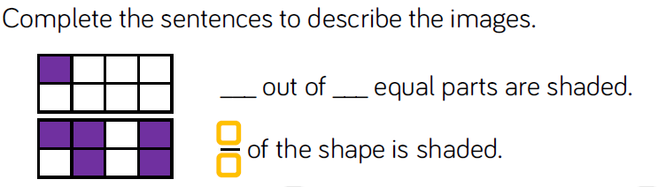  Spicy- I can compare unit fractions to non-unit fractions.  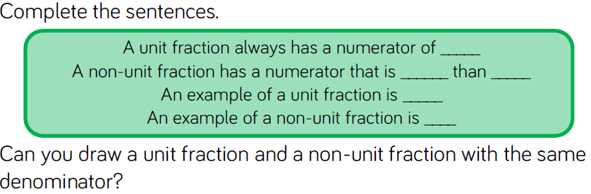  hhh- I can evaluate problems and justify my response.  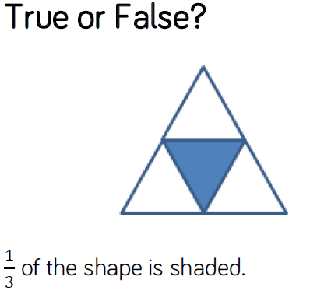
Guided Reading | 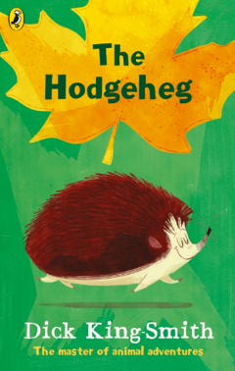  READ CHAPTER 5  What surprised Max at the start of the chapter?  How do we know that Max enjoys being at the park?  Who are the new characters in this chapter? How could we describe them?  What do you predict could happen to Max now he has had ANOTHER bump on the head?  Write a list of all the words you can find that are examples of:  Verbs.  Adjectives.  Adverbs.
Topic | IALT: Investigate Egyptians daily life including the food they ate and their jobs.  https://www.bbc.co.uk/bitesize/topics/zg87xnb/articles/zr4s8xs/  Watch the clip above and read the information about the daily life of Egyptians. Discuss the following questions with a family member or think in your head. You may want to make some notes in your books.  - Compare different jobs – how are they different to our jobs nowadays? Are there any surprises?  - What foods did they used to eat?  - What are the similarities and differences to what we eat now?  Task: Draw a picture of an Egyptian child in your books. Can you label the child with the types of jobs he/she may have done. Then, create a lunchbox for your Egyptian child with the types of food they would have eaten during this time.  Extension: If you have the ingredients, can you make any classic foods from Ancient Egypt? Below is the recipe for Egyptian flatbread:  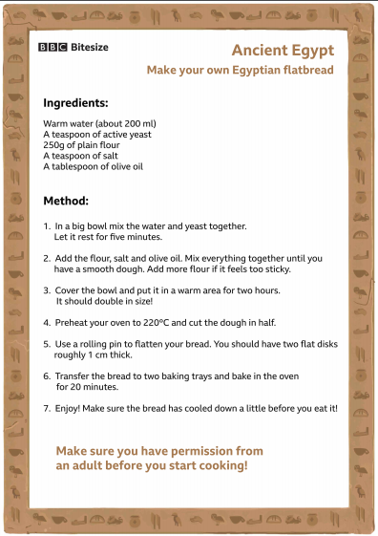  Take pictures of your finished products and send to your class teachers.

Tuesday
English | Starter: Can you think of any double consonants words? Watch the clip below to give you some ideas. Create a list of words along with their meanings (can be found in a dictionary or online)  https://study.com/academy/lesson/what-is-a-double-consonant-words-rule.html  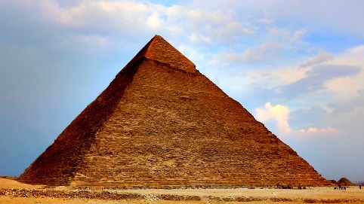  IALT: plan my advert.  Task: Today you will be planning your advert.  - You will need to first, draw a picture of a pyramid.  - Around the edge of your drawing, you need to plan out key words and phrases you will use in your advert.  - These might include things such as; What makes your pyramid better than others to be buried in? Is there anything special or different about your pyramid that could make the Egyptian pharaohs be interested in it?  - Remember to use 2nd person when you are addressing your audience; Egyptian pharaohs.  Extension: Can you include the following key features in your plan? Alliteration, rhetorical questions and imperative verbs.
Maths | IALT: explore the numerator and denominator in fractions.  As for the previous lesson, please make sure that the children are able to access the YouTube channel for any support for this lesson. If the children struggle or do not understand the questions, make sure to email us your concerns.  Mild- I can describe what happens to the denominator and numerator when we make 1 whole.  S-I can prove my theory.  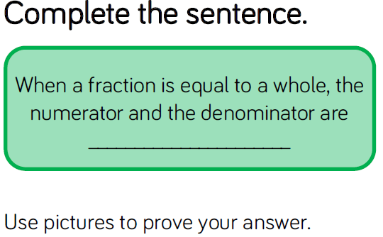  Hhh- I can evaluate problems and justify my response.  Jude is drawing bar models to represent a whole.  He has drawn a fraction of each of his bars.  Can you complete Jude’s bar models?  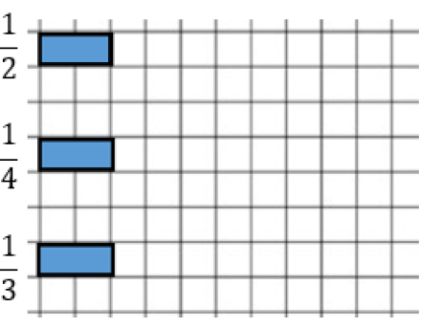
Guided Reading | READ CHAPTER 5  What does 'confronted' mean?  How could we use "to his horror" in our own sentences?  Why is the paragraph from end of page 39 - 40 a good example of describing a setting?  How is a listing effect used on page 41?  How does the author build excitement on page 42?  What does 'inquisitive' mean?  Use the paragraph from the end of page 39 - 40, write your own description of a setting.  Use your senses.  Include the brackets (these show extra information).  Think about using effective vocabulary.
Topic | IALT: Investigate Egyptian writing.  https://www.bbc.co.uk/bitesize/topics/zg87xnb/articles/zvw3mfr  Task:  - Follow the link above and read the information.  - In your books, can you answer the question: What were Egyptian hieroglyphics?  - Using the hieroglyphic alphabet below, can you write you name. You can use the cartouche, which is the oval shape that represents a rope with special powers to ward off evil spirits and keep the name inside of it safe. This was used for the names of Egyptian gods and their royal people.  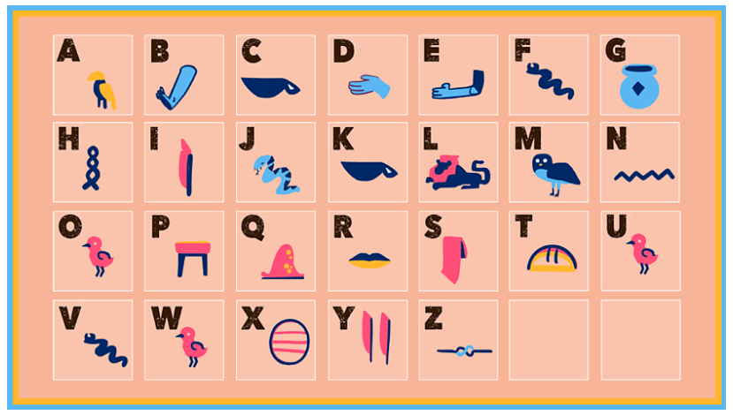  Extension: Research a Egyptian’s God name and write it using the hieroglyphics and cartouche.

Wednesday
English | IALT: write my advert to persuade.  Task: Today you are going to be writing an advert persuading Egyptian pharaohs that your pyramid is the best for them to be buried in! Look back at your plan from yesterday and use your ideas to write your advert. The design of your advert can be chosen by you! Please use images within your advert to make it engaging for the reader.  You may want to use this website to help you with some ideas of what made a great tomb: https://www.bbc.co.uk/newsround/46186614  Below is WAGOLL written by Miss Edwards:  Are YOU looking for your perfect burial pyramid? Then you have come to the right place! In this brand new and exciting tomb, you can find make up kits and perfume for both men and women, rich and poor. Including the unforgettable, popular cosmetic; eyeliner! Not only does this tomb have great make up opportunities it also has a beautifully crafted, golden throne. This is something unique to our tomb, which you will not be able to find anywhere else.  Are you someone that gets hungry easily? Don’t worry we have over 100 baskets overflowing with barley, figs, grapes, melons and many more tasty treats for you in the afterlife. To go alongside your delicious snacks, there will be many jars of tempting wine.  You may magpie some ideas from this WAGOLL but I would also love to see your own ideas.  Extension:  Underline where I have used:  2nd person, expanded noun phrases, -er and -est suffixes, alliteration, rhetorical questions and imperative verbs.  Are there any features I did not include? Can you edit in some examples to improve my writing?
Maths | IALT: recognise and represent tenths.  For better able to answer the following question, please refer to the YouTube channel.  Mild- I can identify and represent tenths.  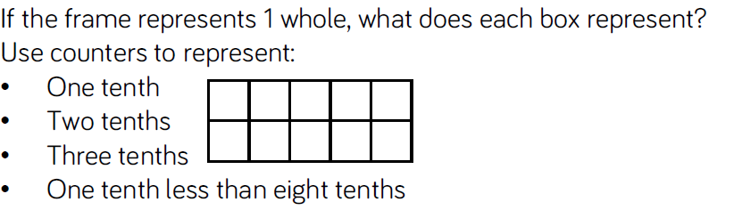  Spicy-I can identify and describe tenths by using words and as a fraction.  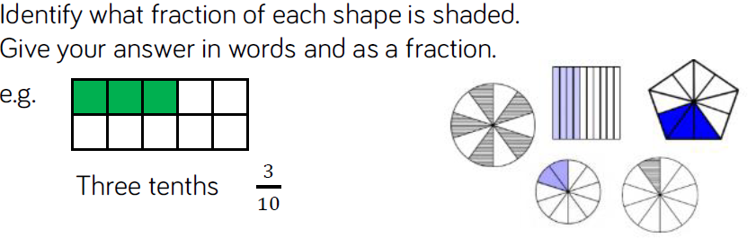  Hhh- I can evaluate word problems.  Alishba has 2 cakes. She wants to share them equally between 10 children. What fraction of the cake will each person get.  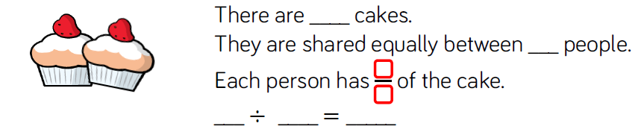  What fraction of the cake would they get if she had 4 cakes?
Guided Reading | READ CHAPTER 6  What could 'bonanza' mean?  What goes 'staggering' tell us?  Why is Pa bloated? What does this mean?  p51 Why is Pa feeling awkward and guilty?  p52 Why are the neighbour's eyes twinkling?  Who's voice could be speaking at the end of the chapter?  Write a letter from Pa to the neighbour apologising for eating his food.  Use dear, from, because.  Use conjunctions and give reasons.  Think about using effective vocabulary and show you feel bad and guilty.
Topic | IALT: Investigate Egyptian clothing.  Read the information below about Egyptian clothing:  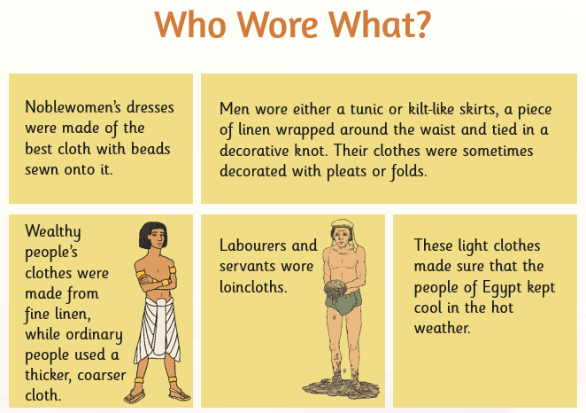  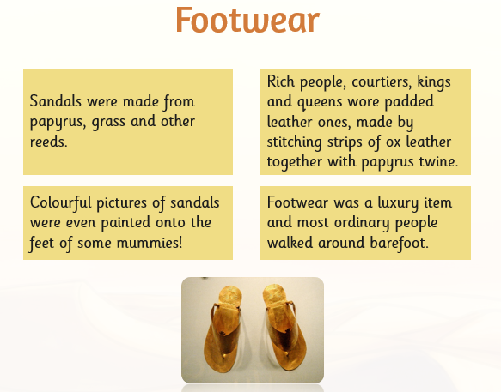  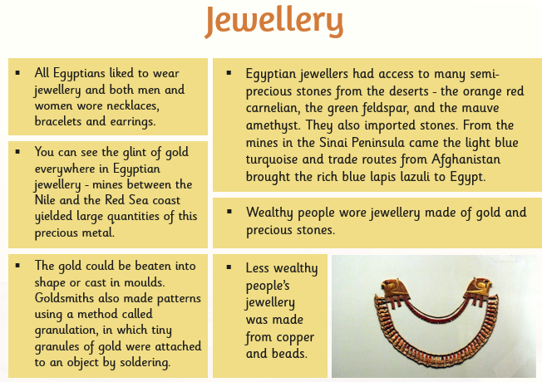  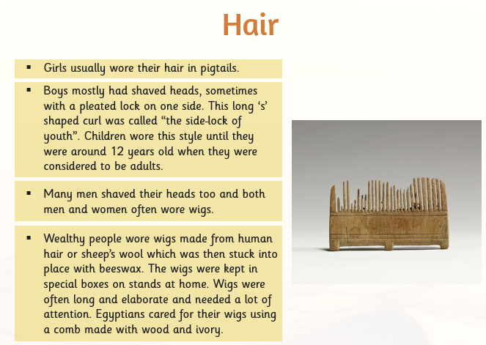  Task: Design and annotate a picture of a male and female in Egyptian clothing. Underneath your drawings, discuss: what are the similarities and what are the differences?  Extension: Can you create something similar to what the Egyptians wore with items in your home?  Remember to take pictures and send them to your teachers!

Thursday
English | IALT: edit and publish my advert.  Task: Go back to your advert from yesterday and read it thoroughly – It’s a good idea to read aloud to someone or to yourself so you can hear what you have written. Can you notice any mistakes you made? Use a purple pen to edit.  - Use a dictionary or the internet to help you correct any spelling mistakes you have made.  - Up level words where you could use better words, such as; ‘great’ to ‘outstanding’.  - Check you have use correct punctuation.  - Have you used our key features? 2nd person, expanded noun phrases, -er and -est suffixes, alliteration, rhetorical questions and imperative verbs.  Once you have edited with a different colour pen, you can publish your advert! Use a new page in your book or a piece of paper. Design your advert so it uses a mixture of writing and images to engage the reader. Draw the things that you have said make your tomb unique and interesting so the reader can see them clearly.  If you have access to a computer you may publish your advert onto a word or publisher document.  Extension: Share your advert with a member of your family. What do they like about it? Would they want to be buried in your pyramid? Is there anything they think could be improved for next time?
Maths | IALT: solve reasoning and problem solving questions.  During this lesson, the children will be shown a strategy on the YouTube channel. Please refer to it for guidance.  Mild- I can fill missing values.  Spicy- I can explain how I find answers.  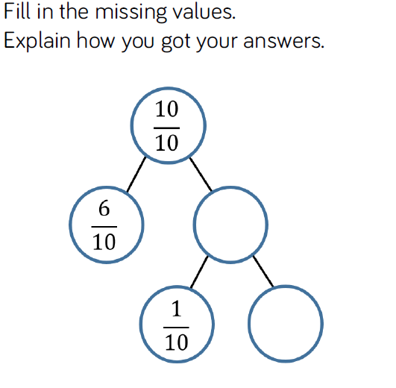  Hhh- I can create my problems.  Here is an example of a problem solving question. Solve it and then create one similar to it.  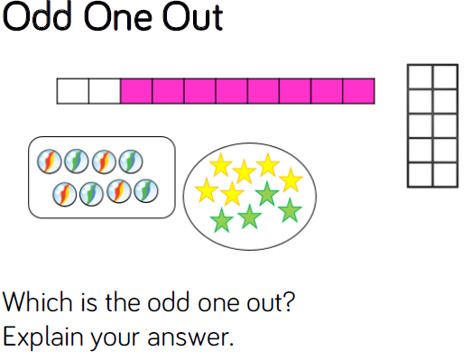
Guided Reading | READ CHAPTER 7  What sentence types are on page 57?  What does 'elderly bachelor' mean?  Why do they call the hedgehog Uncle B?  On page 62, what does 'read his thoughts' mean?  On page 65, what does 'better lose sleep than lose life' mean?  Who are the magical big humans and small humans?  Draw and label Uncle B.  Use adjectives.  Describe his personality.  Explain WHY.
PE | See separate guidance on PE activities.

Friday
English | IALT: use the split digraph for long vowel sounds.  A digraph is two letters (two vowels or two consonants or a vowel and a consonant) which together make one sound (as in the words tail, boat, found or read).  When a digraph is split by a consonant it becomes a split digraph. For example:  wrote – the 'oe' here make one sound. The 'oe' digraph is split by the 't'  lake – the 'ae' here make one sound. The 'ae' digraph is split by the 'k'.  complete – the 'ee' here make one sound. The 'ee' digraph is split by the 't'.  Task: Practise the following spellings – use a method that suits you. Can you highlight where the split diagraph is?  globe  whole  slope  stone  fate  mane  rate  complete  delete  theme
Maths | Assessment:  Every Friday, we will have an assessment of the concepts that were covered that week for the children to complete independently. If they do not score over half of the answers correctly, please email us as we will need to help support your learning.  1)  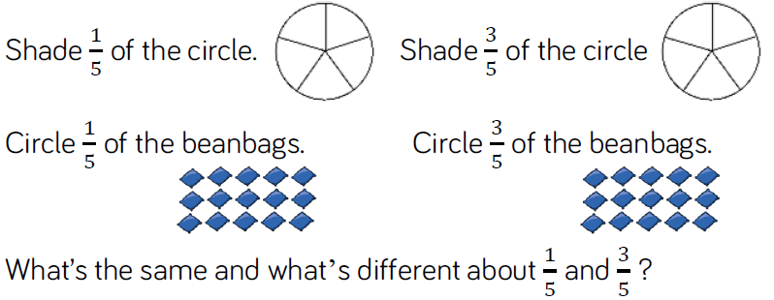  2) I have one pizza and cut it into 6 pieces. I have eaten 6/6 of the pizza. Do I have any left? Explain your answer.  3)  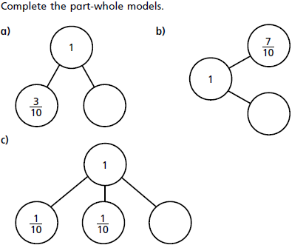
Guided Reading | Accelerated reader – complete a quiz online. Many books you have at home will also be on accelerated reader, search the name to find out if you can do a quiz about one of your own books.  Steps: School website – class pages – Accelerated reader – log in – Accelerated reader
Topic | IALT: Create an Egyptian mask.  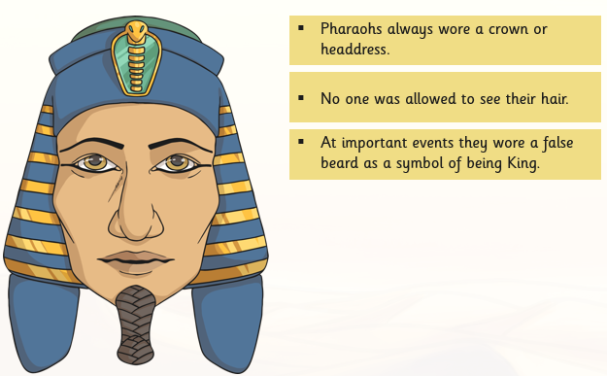  https://www.hobbycraft.co.uk/ideas/kids/how-to-make-an-egyptian-mask  Task: Use the video above as a guide to make an Egyptian mask. You will need: cereal boxes and pens or paint to create mask. Below is an example of WAGOLL:  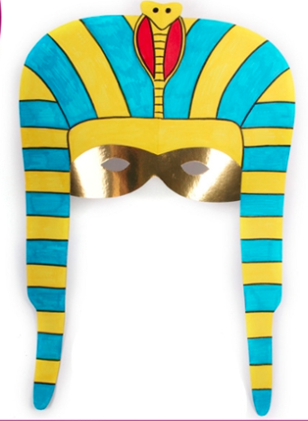  REMEMBER to send your teachers pictures of your mask! We cannot wait to see what you’ve created.

