Monday
English | Starter: Get a parent, sibling or family member to test you on your spellings: driving, hoping, maker, adorable, user, careful, useful, peaceful, likeable, seeing  IALT: spell words using vowel letters.  Can you fill in the missing vowels for the words below?  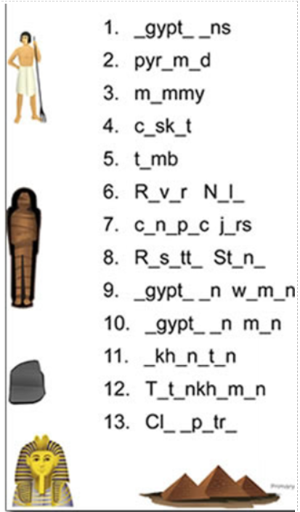
Maths | IALT: understand equivalent fractions.  Please follow the link below and click on “Summer Term - Week 7 (w/c 8th June)”  https://whiterosemaths.com/homelearning/year-3/  Lesson 1: Equivalent fractions (1)  Please watch the video which links to lesson 1 on Equivalent fractions (1).  Please answer the questions modelled in the video in your books  For more activities please follow the link:  https://www.bbc.co.uk/bitesize/articles/znsc86f
Guided Reading | 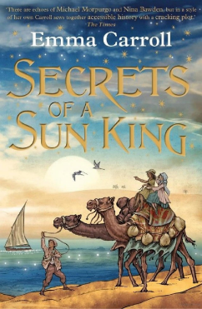  Vocab lesson: Chapter 8  Coincidence – occurring together in space or time.  Insignificant- too small or unimportant to be worth consideration.  Remember to Spell the words, draw, define and use in a sentence
Science | Choose one of your Science activities.

Tuesday
English | IALT: write a time travel story.  This week will be using our planning from last week to write our final stories of Year 3! We will be writing the first three paragraphs today.  Here is the original story and the beginning of Miss Frain’s version:  Paragraph 1  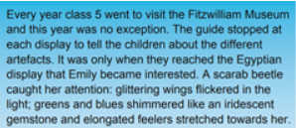  Every year, Year 4 visited the Reading Museum and this year was no different. The clever museum guide stopped at every display to explain the fascinating stories behind each artefact. Jimmy only became intrigued when they reached the Egyptian display. A sarcophagus grabbed his attention: tall and looming over him; golden flakes flickered within the shadows and Jimmy even thought he could hear creaking coming from inside.  Paragraph 2  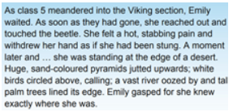  As Class 4 trooped off towards the Viking section, Jimmy lingered behind. As his mouth gaped open at the giant structure before him, he dropped his water bottle with a loud THUD. Water gushed out, splashing the previous artefacts and darkening the sandy colour. Jimmy quickly grabbed at his bottle, not noticing that the water had become so hot that it was boiling and steam was rising up, covering his vision and... suddenly, as Jimmy opened his eyes, he realised he was now standing in a dark and gloomy room, filled with artefacts just as magnificent as the one he had stared at. As he took in the large bricks around him, sandy floor and slanting roof he realised exactly where he was.  Paragraph 3  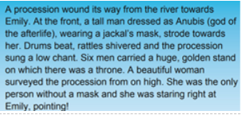  A loud creak filled the air and Jimmy stared in horror as one by one, each sarcophagus began to creep open and bandaged arms reached towards him. Thudding footsteps, crinkling bandages and the heavy scrape of the sarcophaguses opening filled the air. As the mummies emerged from their ancient cocoons, all their unliving eyes stared directly at Jimmy.
Maths | IALT: understand equivalent fractions.  Please follow the link below and click on “Summer Term - Week 7 (w/c 8th June)”  https://whiterosemaths.com/homelearning/year-3/  Lesson 2: Equivalent fractions (2)  Please watch the video which links to lesson 2 on Equivalent fractions (2).  Please answer the questions modelled in the video in your books  For more activities please follow the link:  https://www.bbc.co.uk/bitesize/articles/zbqkvwx
Guided Reading | Watch Miss Parry read Chapter 8 of “Secrets of the Sun King”  https://www.youtube.com/watch?v=utRg8TWL6MA  Recall and retrieval questions.  Is Mr. Carter close to finding Tutankhamun?  Do Lil find it odd when her parents went out for a walk?  Where do her parents go?  What did she want to get from her Mum’s room?  What fell out of the Suitcase?  Remember to answer the questions in full sentences.
Geography | Choose one of your Geography activities.

Wednesday
English | IALT: write a time travel story.  We will be carrying on our stories from yesterday. Reread what you have written and then complete the last 3 paragraphs.  Here is the original and Miss Frain’s version:  Paragraph 4  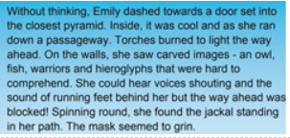  As quick as a flash, Jimmy darted through a large doorway behind him and begun running through the endless passageways. Torches burned brightly, lighting the way. On the walls, he saw hieroglyphs just like the ones he had learnt about at school. He could hear the thudding footsteps speeding up and the cracking of ancient bones moving towards him. On his right, he noticed a small doorway which he quickly leapt through and found himself standing face to face with another sarcophagus.  Paragraph 5/6  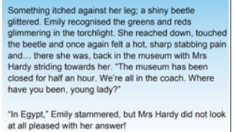  Behind him, he could hear the footsteps speeding up and without thinking, he used all his strength to heave open the cover of the sarcophagus and crept inside. His fingers strained as he pulled back the cover to hide himself. As he leant back, he felt something cold and musty breathing down his neck.... With a screech, he pushed the cover off him again and leapt forward and.... found himself straight back in the museum. The museum guide was looking at him strangely and the rest of his classmates were staring with the mouths open. “Where have you been, Jimmy?” his teacher demanded. “That was not a very good decision to go running off, I will have to speak to your mum about this at the end of the day.”  “NOOOOO NO more mummies, PLEASE!” begged Jimmy but his teacher just stared at him in bewilderment as his friends began to giggle.
Maths | IALT: understand equivalent fractions.  Please follow the link below and click on “Summer Term - Week 7 (w/c 8th June)”  https://whiterosemaths.com/homelearning/year-3/  Lesson 3: Equivalent fractions (3)  Please watch the video which links to lesson 3 on Equivalent fractions (3).  Please answer the questions modelled in the video in your books  For more activities please follow the link:  https://www.bbc.co.uk/bitesize/articles/zbqkvwx
Guided Reading | Watch Miss Parry read Chapter 8 of “Secrets of the Sun King”  https://www.youtube.com/watch?v=utRg8TWL6MA  Questions on Inference Summary:  Why does Lil start to follow her parents when they went for a walk?  Do you think the parents were sad when they went to the Church?  What do you think they were looking at?  What do you think that piece of paper that fell out of the suitcase was?  Remember to answer the questions in full sentences.
PSHE | Choose one of your PSHE activities.

Thursday
English | IALT: publish and present my story.  Make sure you think of a title for your story if you haven't already! Mine is called ‘The Time-Slip Sarcophagus’.  It is time to publish your final stories of Year 3!  Show your drafts to a family member and read them through to check they make sense and do any editing with a coloured pen.  Write your work up neatly on paper.  Take a photo and email it to year3@civitasacademy.co.uk for Miss Edwards and Mr Martinez to see!  WELL DONE!
Maths | IALT: compare fractions.  Please follow the link below and click on “Summer Term - Week 7 (w/c 8th June)”  https://whiterosemaths.com/homelearning/year-3/  Lesson 4: Compare fractions  Please watch the video which links to lesson 4 on comparing fractions.  Please answer the questions modelled in the video in your books  For more activities please follow the link:  https://www.bbc.co.uk/bitesize/articles/zwypqfr
Guided Reading | Task:  Write a prediction paragraph explain what you think that paper is saying:  BOY 8 LBS 6 OZ  BORN 19th NOVEMBER 1899  St. Marys Convent  Islington, London
History | Choose one of your History activities.

Friday
English | Below is a list of all the Year 3 and 4 spelling words. Check which ones you can spell and which ones you may need more practice on.  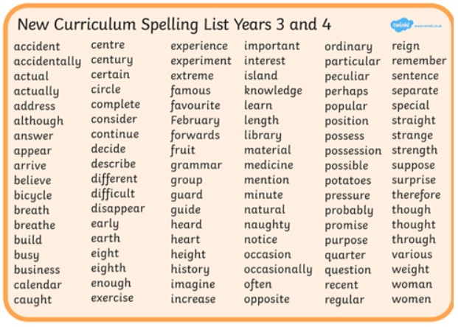
Maths | IALT: reflect on previous Mathematics learning and challenge myself.  Friday Maths challenge:  https://www.bbc.co.uk/bitesize/articles/zmtx8hv  - Follow the link above and watch the clip discussing data handling in Football.  - Look through the slideshow to remind yourself about the important parts of data handling  - Complete activity 1 – quiz  - Complete activity 2 – practise drawing charts  - Complete activity 3 – record and display your results  Look out for the answer sheets to mark your work in purple pen
Guided Reading | Accelerated reader – complete a quiz online. Many books you have at home will also be on accelerated reader, search the name to find out if you can do a quiz about one of your own books.  Steps: School website – class pages – Accelerated reader – log in – Accelerated reader
Art | Choose one of your Art activities.

