Monday
English | Starter: Get a parent, sibling or family member to test you on your spellings: no, know, paw, poor, there, they’re, their, to, too, two  IALT: correct spellings accurately.  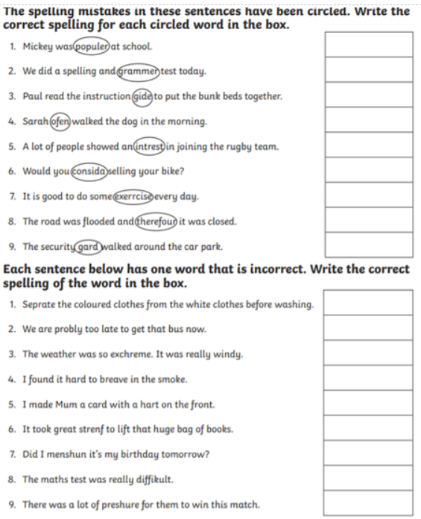
Maths | IALT: understand tenths as decimals  Please follow the link below and click on “Summer Term - Week 6 (w/c 1st June)”  https://whiterosemaths.com/homelearning/year-3/  Lesson 1: Tenths as decimals  Please watch the video which links to lesson 1 on Tenths as decimals.  Please answer the questions modelled in the video in your books  For more activities please follow the link:  https://www.bbc.co.uk/bitesize/articles/zmcny9q
Guided Reading | 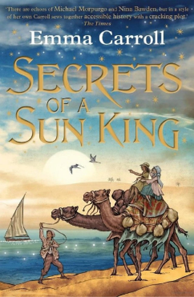  Vocab lesson: Chapter 7 – part 2  Chariot – a two-wheeled vehicle drawn by horses, used in ancient racing and warfare.  Sandalwood- a widely used Indian tree that yields fragrant timber and oil.  Regal-looking like a KING or a QUEEN, especially in being magnificent or dignified.  Sand storm- a windstorm, especially in a desert, that blows along great clouds of sand (distinguished from dust storm).  Magnificent- means extremely beautiful, elaborate, or impressive.  Remember to Spell the words, draw, define and use in a sentence
Science | Choose one of your Science activities.

Tuesday
English | IALT: create a story map.  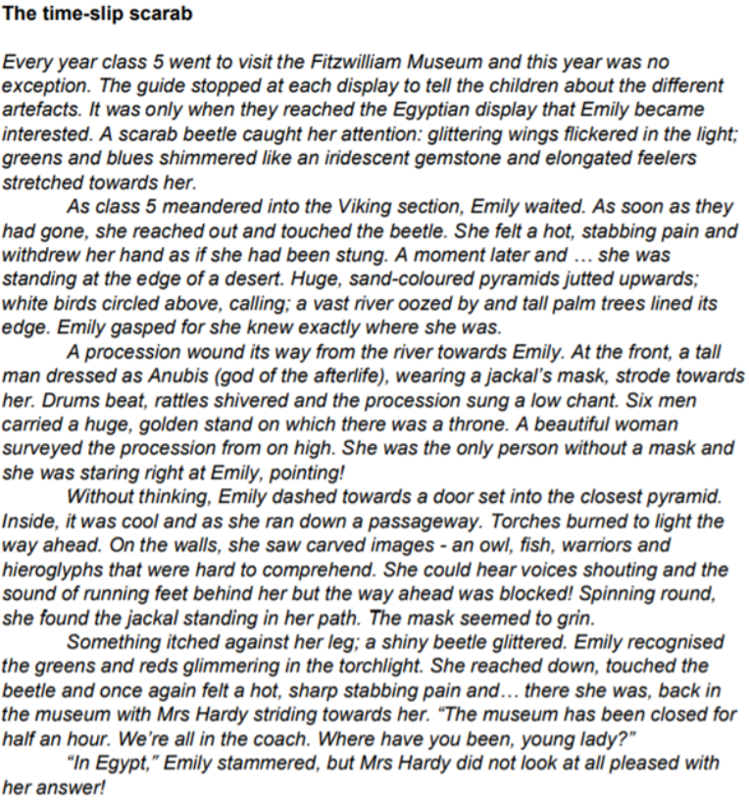  Task: Create a story map of ‘The Time-Slip Scarab  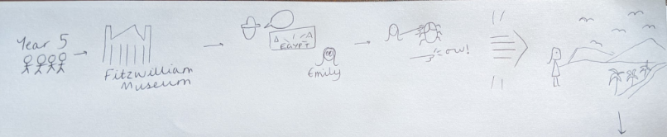  Here is an example of the start of Miss Frain’s story map. Complete the rest:
Maths | IALT: understand fractions on a number line.  Please follow the link below and click on “Summer Term - Week 6 (w/c 1st June)”  https://whiterosemaths.com/homelearning/year-3/  Lesson 2: Fractions on a number line  Please watch the video which links to lesson 2 on fractions on a number line.  Please answer the questions modelled in the video in your books  For more activities please follow the link:  https://www.bbc.co.uk/bitesize/articles/zm8g47h
Guided Reading | Watch Miss Parry read Chapter Seven – part 2 of “Secrets of the Sun King”  https://www.youtube.com/watch?v=3JftbWgfuJs  Recall and retrieval questions.  Who was racing on the race day?  What did the King look like in his chariot?  What happened to the Kings Chariot?  Does Lysandra think this is an accident?  Is Ay nice to the King?  Remember to answer the questions in full sentences.
Geography | Choose one of your Geography activities.

Wednesday
English | IALT: innovate a story.  We will be creating our own versions of ‘The Time-Slip Scarab’ so we will change some parts of the story.  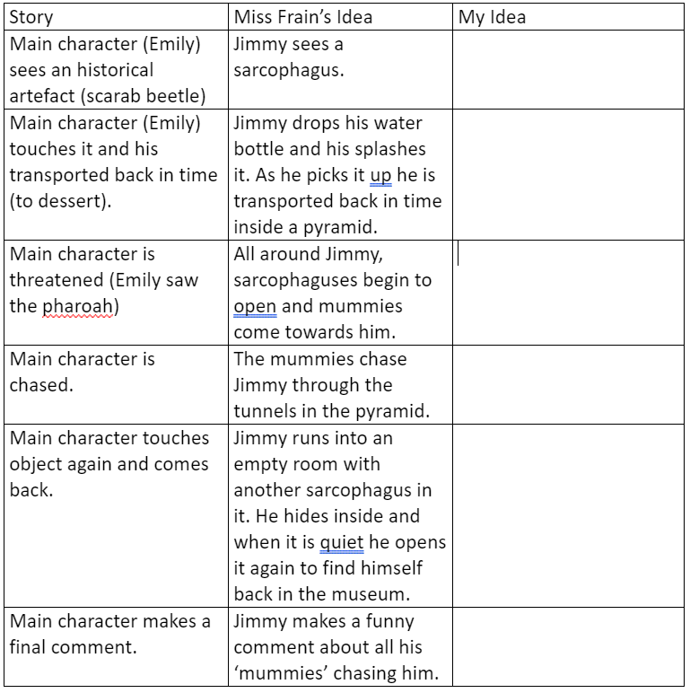  Here are the main ideas from the story which we will change. You can see how Miss Frain has decided to change it and think about how you will change it.
Maths | IALT: understand fractions of a set of objects.  Please follow the link below and click on “Summer Term - Week 6 (w/c 1st June)”  https://whiterosemaths.com/homelearning/year-3/  Lesson 3: Fractions of a set of objects (1)  Please watch the video which links to lesson 3 on Fractions of a set of objects (1).  Please answer the questions modelled in the video in your books  For more activities please follow the link:  https://www.bbc.co.uk/bitesize/articles/zm6rkxs
Guided Reading | Watch Miss Parry read Chapter Seven – part 2 of “Secrets of the Sun King”  https://www.youtube.com/watch?v=3JftbWgfuJs  Questions on Inference Summary:  How does Lysandra feel before and during the race?  Why does Lysandra know the stable boy did not break the Kings chariot?  How does she feel towards the King?  Does you think Lysandra can see the future with her dreams?  Remember to answer the questions in full sentences.
PSHE | Choose one of your PSHE activities.

Thursday
English | IALT: plan my story.  Using our ideas from yesterday we will create a story map to help us write up our story next week.  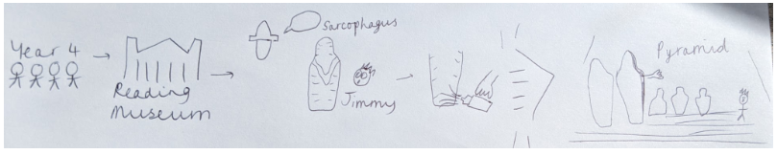  Here is the first part of Miss Frain’s story, using the ideas she came up with yesterday:  When you have finished, box it up into paragraphs and check you have added lots of exciting vocabulary on to it. Can you tell your story to a family member to check it makes sense?
Maths | IALT: understand fractions of a set of objects.  Please follow the link below and click on “Summer Term - Week 6 (w/c 1st June)”  https://whiterosemaths.com/homelearning/year-3/  Lesson 3: Fractions of a set of objects (2)  Please watch the video which links to lesson 3 on Fractions of a set of objects (2).  Please answer the questions modelled in the video in your books  For more activities please follow the link:  https://www.bbc.co.uk/bitesize/articles/zm6rkxs
Guided Reading | Task:  The King has had an accident in his Chariot and the local Egyptian newspaper needs to report it. Create an article that will describe what happened to the King, who was the master mind behind hurting the King and how is the King recovering.
History | Choose one of your History activities.

Friday
English | Task: Practise the following spellings – use a method that suits you. You will be tested on these on Monday 13th July.  What suffixes can you see in your spellings for next week? Make a list and see if you know the meaning of those suffixes.  driving, hoping, maker, adorable, user, careful, useful, peaceful, likeable, seeing
Maths | IALT: reflect on previous Mathematics learning and challenge myself.  Friday Maths challenge:  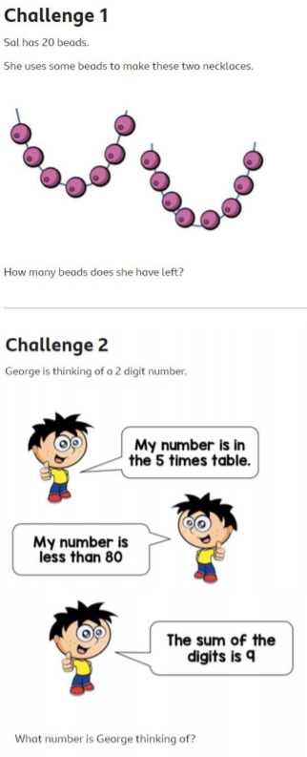  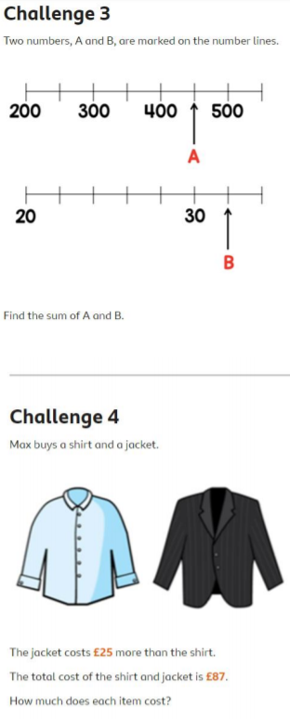  ANSWERS:  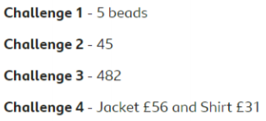
Guided Reading | Accelerated reader – complete a quiz online. Many books you have at home will also be on accelerated reader, search the name to find out if you can do a quiz about one of your own books.  Steps: School website – class pages – Accelerated reader – log in – Accelerated reader
Art | Choose one of your Art activities.

