Monday
English | Starter: Get a parent, sibling or family member to test you on your spellings: new, knew, threw, through, for, four, be, bee, one, won  IALT: correct spellings accurately.  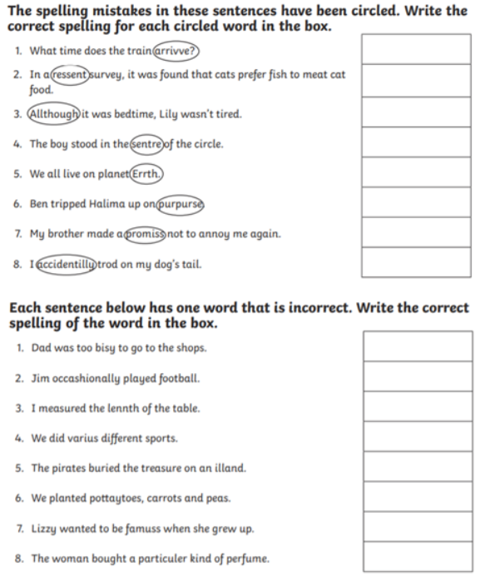
Maths | IALT: use unit and non-unit fractions.  Please follow the link below and click on “Summer Term - Week 5 (w/c 18th May)”  https://whiterosemaths.com/homelearning/year-3/  Lesson 1: Unit and non-unit fractions.  Please watch the video which links to lesson 1 on unit and non-unit fractions.  Please answer the questions modelled in the video in your books
Guided Reading | 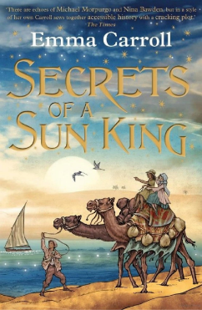  Vocab lesson: Chapter 7 – part 1  Assumed- suppose something is meant to be the case, without proof.  Luxor- a city in eastern Egypt, on the east bank of the River Nile.  Occurred- happen or taken place.  Complexion- the natural colour, texture, and appearance of a person's skin, especially of the face.  Hesitated- pause in indecision before saying or doing something.  Remember to Spell the words, draw, define and use in a sentence
Science | Choose one of your Science activities.

Tuesday
English | IALT: explore vocabulary.  This week we will be looking at a short story called ‘The Time-Slip Scarab.  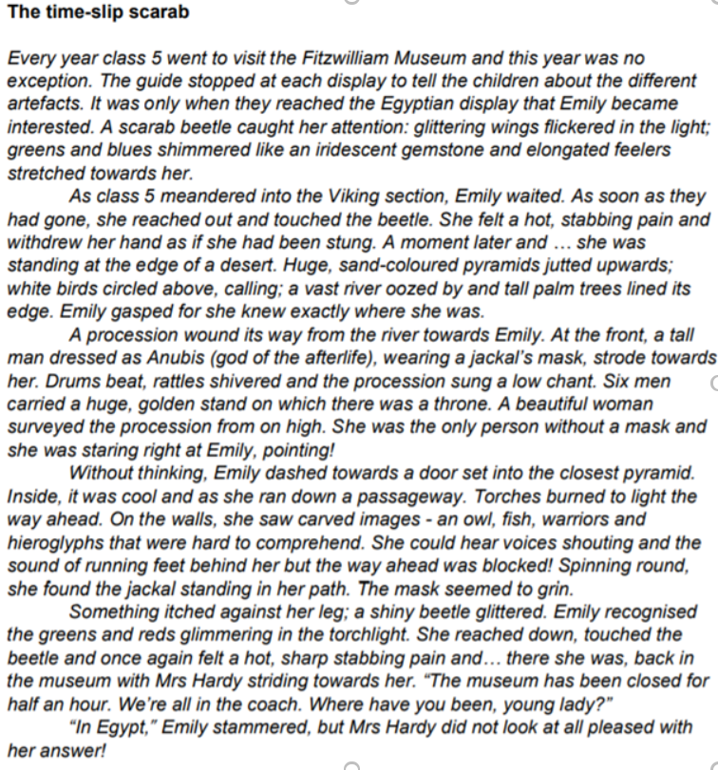  Task 1: take a coloured pencil and colour in any vocabulary you are unsure of OR write it out in a list. Use an online dictionary to help you find the meaning of these words.  Task 2: Using another colour or a new list, look for any ‘wow’ words that have been used- hunt out that great vocabulary!
Maths | IALT: Make the whole.  Please follow the link below and click on “Summer Term - Week 5 (w/c 18th May)”  https://whiterosemaths.com/homelearning/year-3/  Lesson 2: Making the whole  Please watch the video which links to lesson 2 on making the whole.  Please answer the questions modelled in the video in your books
Guided Reading | Watch Miss Parry read Chapter Seven – part 1 of “Secrets of the Sun King”  https://www.youtube.com/watch?v=fydM4e2SNAc  Recall and retrieval questions.  Who does Tulip say she’s related too?  Does the Policeman believe her?  How does Lil get into Professor Hanawati’s house?  What did Lil feel about the Ash on the floor?  Does Lil find the rest of the translation?  Remember to answer the questions in full sentences.
Geography | Choose one of your Geography activities.

Wednesday
English | IALT: understand a text (part 1)  Read the short story again and answer the questions in full sentences.  ● What does the author mean by ‘this year was no exception’?  ● At the start of the story, how did Emily feel and how do we know?  ● Describe what it was about the beetle that caught her eye.  ● Why do you think she touched the beetle?  ● How did she know so quickly where she was?  ● What is the possible effect of the words ‘rattles shivered’?  ● Where is the woman sitting and how do you know?  ● What does the fact that she has no mask suggest?  ● Explain the word ‘surveyed’. What does it suggest about the woman?  ● What do the exclamation marks indicate?
Maths | IALT: understand tenths  Please follow the link below and click on “Summer Term - Week 5 (w/c 18th May)”  https://whiterosemaths.com/homelearning/year-3/  Lesson 3: Tenths  Please watch the video which links to lesson 3 on Tenths.  Please answer the questions modelled in the video in your books
Guided Reading | Watch Miss Parry read Chapter Seven – part 1 of “Secrets of the Sun King”  https://www.youtube.com/watch?v=fydM4e2SNAc  Questions on Inference Summary:  How does Lil feel she notice the place where Professor Hanawati died?  Does she like being in that house alone?  What are her emotions when she finds the blue paper under the chair?  What do you think the translation will say?  Remember to answer the questions in full sentences.
PSHE | Choose one of your PSHE activities.

Thursday
English | IALT: understand a text (part 2).  Read the story again and answer the questions in full sentences:  ● It was cool inside. What does that suggest about outside?  ● How does the author make it seem as though Emily has no hope of escape?  ● Does the mask grin? Explain what you think the sentence is suggesting – what impression is the author trying to create?  ● Explain the choice of the word, ‘striding’.  ● Explain what Mrs Hardy thinks about Emily.  ● Why does the author use ellipsis?  ● Describe Emily’s feelings as they change across the story and use quotes to support your ideas.
Maths | IALT: Count in tenths.  Please follow the link below and click on “Summer Term - Week 5 (w/c 18th May)”  https://whiterosemaths.com/homelearning/year-3/  Lesson 4: Count in tenths  Please watch the video which links to lesson 4 on Count in tenths  Please answer the questions modelled in the video in your books
Guided Reading | Task:  Design Professor Hanawati’s study. Make it fashionable for the 1916 period. Think about what would be in a study. Why would it look dark and gloomy?
History | Choose one of your History activities.

Friday
English | Task: Practise the following spellings – use a method that suits you. You will be tested on these on Monday 6th July. Can you use an online dictionary to help you understand what they all mean? Can you use them in a sentence?  What are homophones? Do you know any other examples?  no, know, paw, poor, there, they’re, their, to, too, two
Maths | IALT: reflect on previous Mathematics learning and challenge myself.  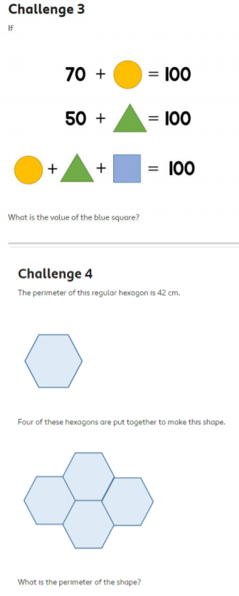  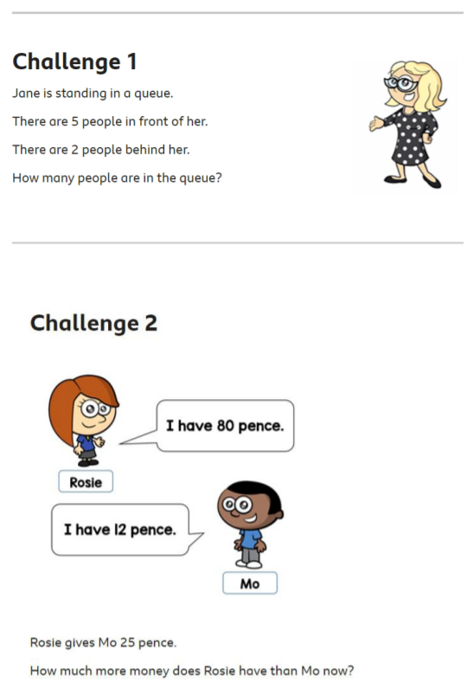  Friday Maths challenge:  ANSWERS:  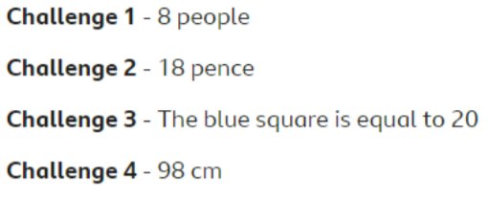
Guided Reading | Accelerated reader – complete a quiz online. Many books you have at home will also be on accelerated reader, search the name to find out if you can do a quiz about one of your own books.  Steps: School website – class pages – Accelerated reader – log in – Accelerated reader
Art | Choose one of your Art activities.

