Monday
English | Starter: Get a parent, sibling or family member to test you on your spellings:  interact, intercept, interlock, interrupt, interval, interview, internet, international, internal, interest  IALT plan by using a boxed up technique  This lesson will be modelled on the YouTube channel.  Children will need to create a box to help them plan. They need to look at the paragraphs from the last week’s text and look at what each paragraph main theme is. In addition, they need to start to think about which features they could include, from the ones that were discussed last week (complex sentences, expanded noun phrases, prepositions and adverbials).  Model of boxed up  Paragraph 1 First impression of the tomb Gramma features  Paragraph 2  Build tension and continue to describe tomb  Paragraph 3  Continue to describe the tomb and finish
Maths | IALT: multiply and divide by 4 and 8.  Please follow the link below and click on “Summer Term - Week 4 (w/c 11th May)”  https://whiterosemaths.com/homelearning/year-3/  Lesson 1: Multiplying and dividing by 4 and 8  Please watch the video which links to lesson 1 on multiplying and dividing by 4 and 8.  Please answer the questions modelled in the video in your books
Guided Reading | 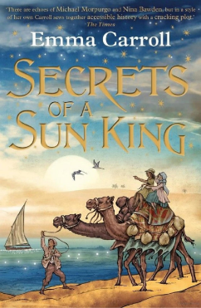  Vocab lesson: Chapter 6  Connected- related in some respect.  Archaeologists- a person who studies human history.  Satchel- a bag carried on the shoulder by a long strap and closed by a flap, used especially for school books.  Panes- a single sheet of glass in a window or door.  Journalists- a person who writes for newspapers, magazines, or news websites or prepares news to be broadcast.  Remember to Spell the words, draw, define and use in a sentence
Science | Choose one of your Science activities.

Tuesday
English | IALT write the 1st draft of my text  Now, that you have learnt a lot about different grammatical and structural features, it is now time for you to have a go at writing your 1st draft. You can decide to use many of the ideas from your cold task and improve as much as you can on that or you can simply decide to create a whole new draft all together. You will be using this text for the next few lessons to improve on. Try to do your best, however, do not worry too much about the final quality, yet.  In terms of how much writing you are expected to write, try and write as much as you can but make sure that it is the best quality writing as you possibly can.
Maths | IALT: multiply 2 digit numbers by 1 digit numbers.  Please follow the link below and click on “Summer Term - Week 4 (w/c 11th May)”  https://whiterosemaths.com/homelearning/year-3/  Lesson 2: multiply 2 digits by 1 digit  Please watch the video which links to lesson 2 on multiplying 2 digits by 1 digit. Please answer the questions modelled in the video in your books
Guided Reading | Watch Miss Parry read Chapter Six of “Secrets of the Sun King”  https://www.youtube.com/watch?v=-DGk1LgaprM  Recall and retrieval questions.  Does Lil lie to her dad about the cat?  Where does Lil go to get her satchel back?  Is Tulip and Oz posh? If so, what does it say in the text for you to think this.  What does Mrs. Mendoza do for a job?  Is she annoyed that she can’t go and cover the story of King Tut.  Remember to answer the questions in full sentences.
Geography | Choose one of your Geography activities.

Wednesday
English | IALT edit efficiently  Video of the first task will be posted on YouTube channel to help you identify if you have edited the text as best as possible.  - Today there will be two tasks. The first one, you will have to edit as best as you can the following draft in your book.  - After you have done that, you will be asked to edit your own. You can send it your edited copy to your teacher to evaluate how effective you have been in your editing process. This is the most important part of the writing, along with planning.  Task to be edited:  Standing a couple of footsteps away from this old, bronze looking tomb, I felt nervous to enter first in case something mysterius or dangerus is inside but if I face my fears, I don’t know what’s instore for me…  Meanwhile, I was in this mysterius looking tomb and I was filled with excitement. Afterwards, I started looking around at the entrance when I herd a huge BANG as the door shut behind me. I was feeling proud but afraid at the same time. As I entered a gloomy, spooky passage, I felt the cool hieroglyphics on the dusty wall. Eventually, I saw a room and on the door, it said “Beautiful house” on it. It stunk of oil. I checked the archaeologist book to see what else to find.
Maths | IALT: divide a 2-digit number by a 1-digit number.  Please follow the link below and click on “Summer Term - Week 4 (w/c 11th May)”  https://whiterosemaths.com/homelearning/year-3/  Lesson 3: divide a 2-digit number by a 1-digit number  Please watch the video which links to lesson 3 on dividing a 2-digit number by a 1-digit number. Please answer the questions modelled in the video in your books
Guided Reading | Watch Miss Parry read Chapter Six of “Secrets of the Sun King”  https://www.youtube.com/watch?v=-DGk1LgaprM  Questions on Inference Summary:  Why is Lil shocked that Mrs. Mendoza say reporting on King Tut is a “mans job”?  Does Lil agree with this?  What is the plan to get the jar to Egypt?  Do they children think the plan is going to work?  Can Lil go to Egypt with them?  Remember to answer the questions in full sentences.
PSHE | Choose one of your PSHE activities.

Thursday
English | IALT edit efficiently  Because editing is so important, we are going to spend two days. This is the time for you to take the feedback from your teachers from the previous lesson and now apply this to your own writing. Make sure to re-write your new draft in a new page to keep your drafts separate.  You may want to send this copy back to your teacher just to check that you have edited correctly. Tomorrow, you will be writing the final draft so this is a very important last step before that.
Maths | IALT: multiply and divide using my problem solving skills.  Please follow the link below and click on “Summer Term - Week 4 (w/c 11th May)”  https://whiterosemaths.com/homelearning/year-3/  Lesson 4: Multiplication and division problem solving  Please watch the video which links to lesson 3 on multiplication and division problem solving. Please answer the questions modelled in the video in your books
Guided Reading | Task:  Design the plane ticket that they would need to fly to Egypt. What would it look like? What airport would they fly into?
History | Choose one of your History activities.

Friday
English | Task: Practise the following spellings – use a method that suits you. You will be tested on these on Monday 29th June.  What are homophones? Do you know any examples?  new, knew, threw, through, for, four, be, bee, one, won  IALT write my final draft  Today, is the last day of this writing unit. You have reviewed many different grammatical features and you have planned and edited your draft. Today, you are going to write the final draft.  When you have finished your final draft today, I would like you to look back at your cold task and write a small evaluation. Have you improved in your writing? What has been the biggest improvement? What did you find the most helpful lesson? Why?
Maths | IALT: reflect on previous Mathematics learning and challenge myself.  Friday Maths challenge:  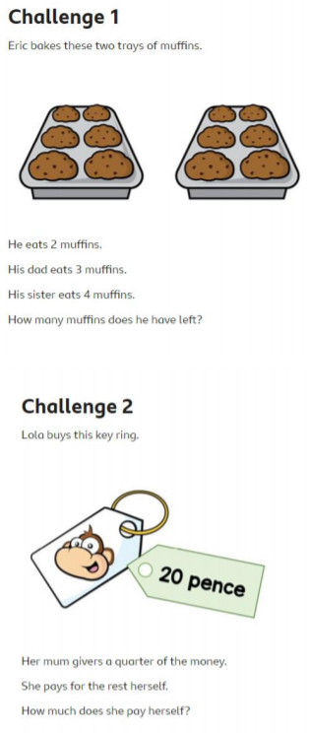  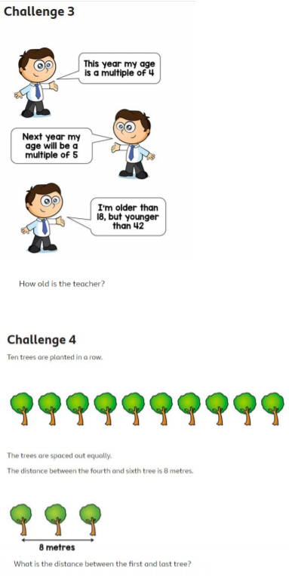  ANSWERS:  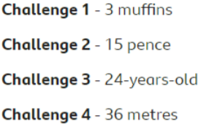
Guided Reading | Accelerated reader – complete a quiz online. Many books you have at home will also be on accelerated reader, search the name to find out if you can do a quiz about one of your own books.  Steps: School website – class pages – Accelerated reader – log in – Accelerated reader
Art | Choose one of your Art activities.

