Choice of tasks for your Independent Home Learning
TOPIC: Dinosaurs

 | What do I know and understand? | Can I apply and show what I know? | What can I create?
I enjoy reading and writing.  This Photo by Unknown Author is licensed under CC BY-SA-NC | Write a fact file about two different dinosaurs – write about their similarities and differences. | Write a dinosaur inspired story – think of how the different dinosaurs will feel about each other. Will they be friends? Will they go on an adventure? | Create a poster for a dinosaur day event! Where is it taking place? What time? What day? Which dinosaurs are they going to see?
I enjoy painting, drawing and creating.  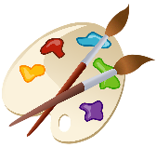 | Draw a picture of your favourite dinosaurs – think about where the dinosaurs live. Make it as detailed as possible. | Make a dinosaur model using different materials. Can you make it move? How can you make it look like a real dinosaur? | Can you use natural resources (leaves, stones, sticks) to make a dinosaur inspired picture.
I enjoy being active and doing hands-on activities.  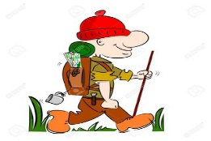  This Photo by Unknown Author is licensed under CC BY-SA | Use dinosaur toys and models to act out a dinosaur inspired story! Can you make a dinosaur “movie” with help from your family? | Be a palaeontologist for the day! Go digging and see if you can find any bones or fossils anywhere? Take pictures of what you find (check you are allowed to dig with your grown up before digging) | 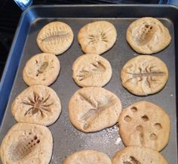  Create dinosaur fossil biscuits with your family.
Please select one or two of the activities listed above and send your work into class by Friday 5th February 2021.
5 house points for one activity
10 house points for more than two activities

