**Conjunctions Workshop**

**Activity 1**

Read the sentence and add in the correct conjunction:

|  |  |  |
| --- | --- | --- |
| **and** | **but** | **or** |

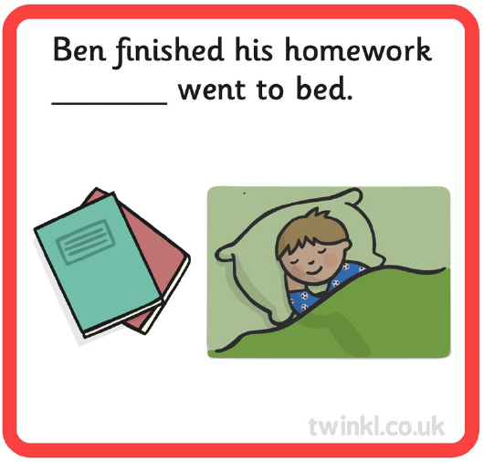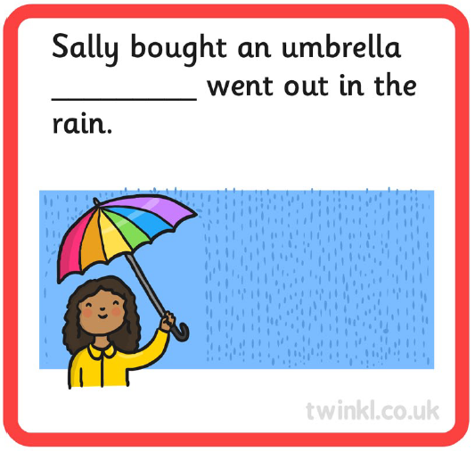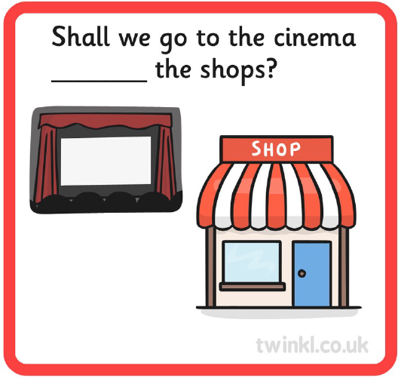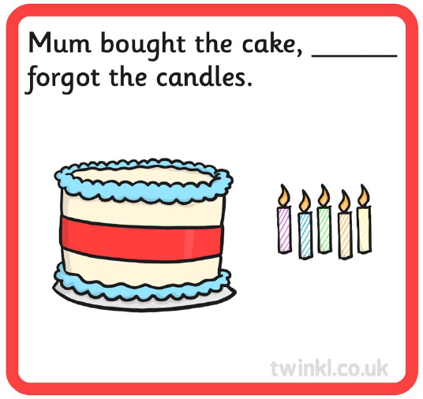

What is a conjunction?  
A conjunction is a word used to join two sentences or clauses together.   
There are lots of “types” of conjunctions, but for now the children are mostly learning about the following conjunctions:

* and
* or
* but

This [video](https://www.youtube.com/watch?v=nNGiDfCX7PI) explains to your child what a conjunction is and when it is used.

We have complied some additional workshops to go through with your children. If you feel your child is confident with this concept then you are under no obligation to do so, we just feel that this may help consolidate their knowledge.

**Activity 2**

Write your own sentences using each of the conjunctions.

|  |  |  |
| --- | --- | --- |
| **and** | **but** | **or** |

For example:

I like to play football **but** my brother prefers tennis.

You can have an apple **or** a banana.

The giraffe has a long neck **and** enjoys eating leaves.

Use the pictures to inspire you, or think of your own:  
[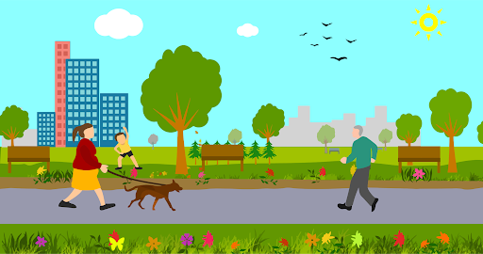](https://www.google.com/url?sa=i&url=http%3A%2F%2Fclipart-library.com%2Fthe-park-cliparts.html&psig=AOvVaw1UcJqLXe721VoLfnGy9Hjb&ust=1610469365071000&source=images&cd=vfe&ved=0CAIQjRxqFwoTCODkkYaolO4CFQAAAAAdAAAAABAD)

[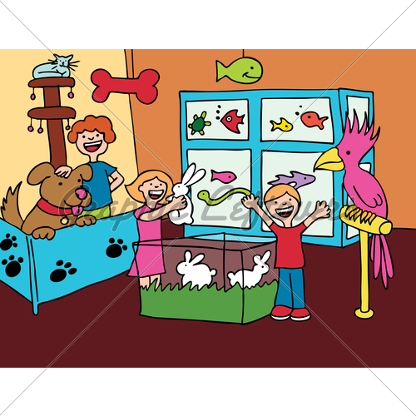](https://www.google.com/url?sa=i&url=https%3A%2F%2Fglstock.com%2Fgraphic%2FPet-Store-Visit1%2F&psig=AOvVaw2lhgJ0XDllwfaoowuHrK2J&ust=1610469437280000&source=images&cd=vfe&ved=0CAIQjRxqFwoTCJCul7KolO4CFQAAAAAdAAAAABAN)