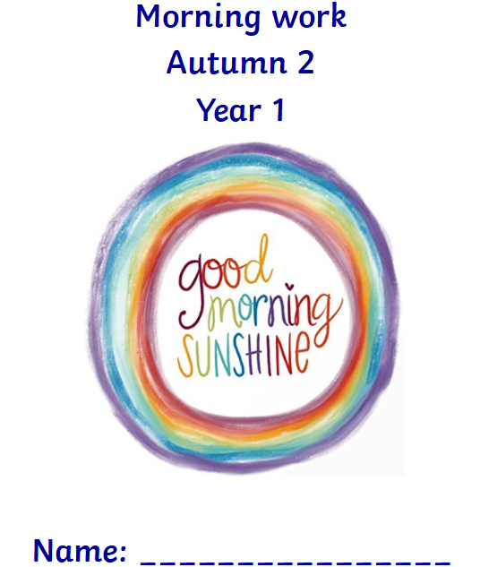

[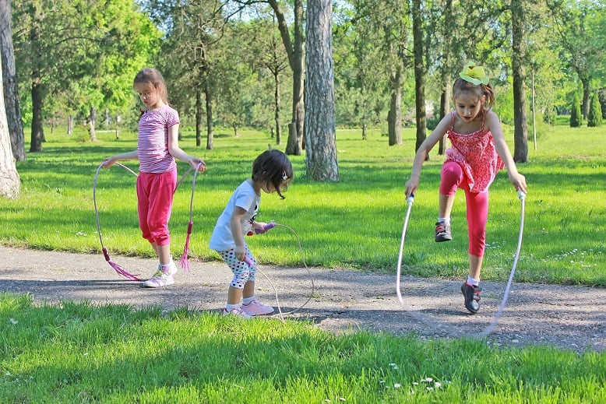](https://www.google.co.uk/url?sa=i&url=https%3A%2F%2Ftheamazingjumprope.com%2Fteach-your-child-how-to-jump-right-way-in-5-steps%2F&psig=AOvVaw0Uc79mP296Ih3DYZBF09Eb&ust=1600249342396000&source=images&cd=vfe&ved=0CAIQjRxqFwoTCPCrsL_v6usCFQAAAAAdAAAAABAK)

[](https://www.google.co.uk/url?sa=i&url=https%3A%2F%2Fpawversity.com%2Fbreeds%2Fthe-best-dogs-for-children&psig=AOvVaw3YcslnzTHfT9hCd74bFpZF&ust=1600249635932000&source=images&cd=vfe&ved=0CAIQjRxqFwoTCKD7hM7w6usCFQAAAAAdAAAAABAD)

[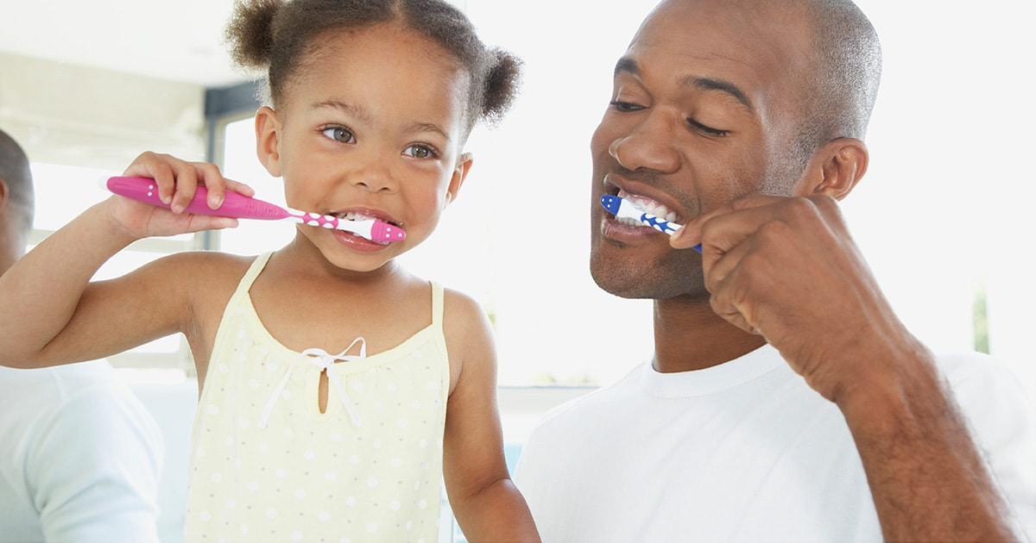](https://www.google.co.uk/url?sa=i&url=https%3A%2F%2Fwww.exxonmobil.com%2Fen%2Fwhiteoil%2Findustry-solutions%2Fadhesives-and-elastomers&psig=AOvVaw0r_ylFdYF0xcHR_GJP9cfS&ust=1600249818314000&source=images&cd=vfe&ved=0CAIQjRxqFwoTCIiY56jx6usCFQAAAAAdAAAAABAO)

[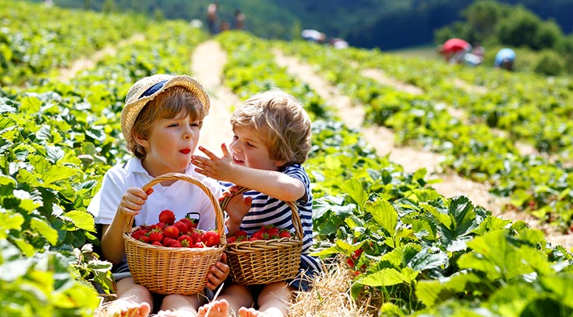](https://www.google.co.uk/url?sa=i&url=https%3A%2F%2Fwww.parkdeanresorts.co.uk%2Famazing-memories%2Fdays-out%2Fpick-your-own-fruit-farms%2F&psig=AOvVaw0O5AeqlGI4ofteIBIrjDW-&ust=1600250074992000&source=images&cd=vfe&ved=0CAIQjRxqFwoTCKCu16fy6usCFQAAAAAdAAAAABAJ)

[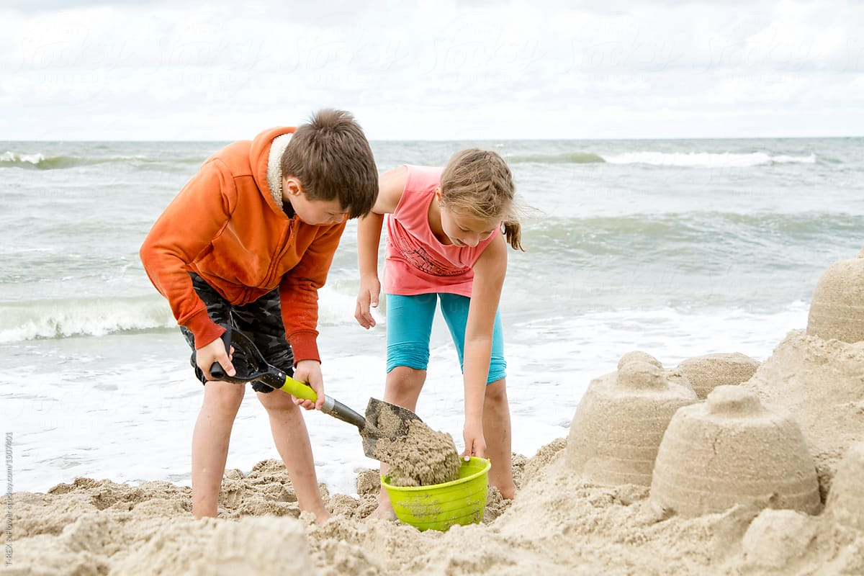](https://www.google.co.uk/url?sa=i&url=https%3A%2F%2Fwww.stocksy.com%2F1507401%2Fchildren-making-castle-with-sand&psig=AOvVaw2niwFCc1z7uG77N46yHlSs&ust=1600886688548000&source=images&cd=vfe&ved=0CAIQjRxqFwoTCKjf_-q1_esCFQAAAAAdAAAAABAg)

[](https://www.google.co.uk/url?sa=i&url=https%3A%2F%2Fwww.shumee.in%2Fblogs%2Fnews%2Fplaying-in-the-rain-create-a-splash-through-free-play-and-learning&psig=AOvVaw3FJQjc4uWymTjVBuaW30iJ&ust=1600714019887000&source=images&cd=vfe&ved=0CAIQjRxqFwoTCPCFncuy-OsCFQAAAAAdAAAAABAP)

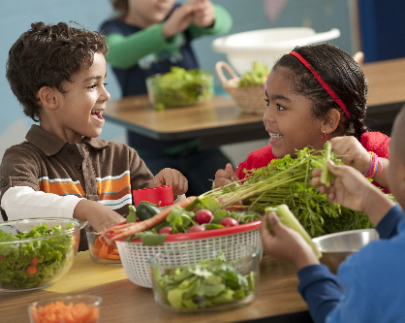

[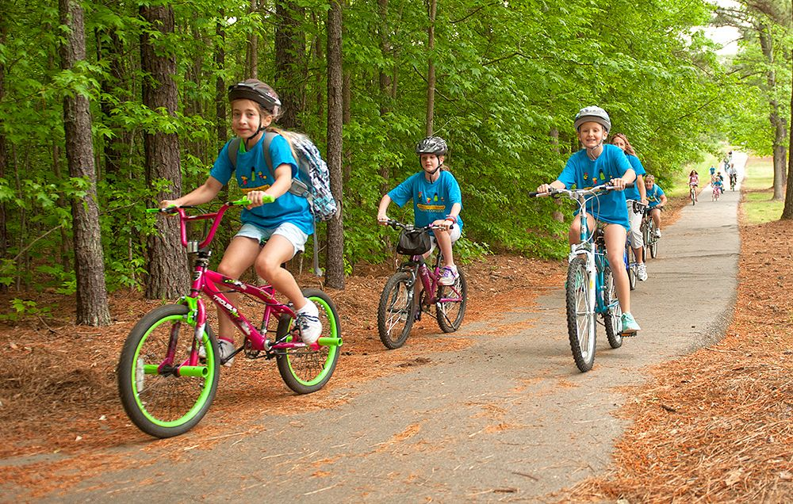](https://www.google.co.uk/url?sa=i&url=https%3A%2F%2Fwww.bicycling.com%2Fnews%2Fa20031077%2Fmore-kids-ride-bikes-to-schools-with-these-3-things%2F&psig=AOvVaw0_TKI6cN7g1lsIuKgMD3jy&ust=1600886990661000&source=images&cd=vfe&ved=0CAIQjRxqFwoTCJCpqP22_esCFQAAAAAdAAAAABAD)

[](https://www.google.co.uk/url?sa=i&url=https%3A%2F%2Fmusicearlychildhoodpresenter.com%2Fblog%2Fthe-gift-of-reading-celebrating-childrens-book-week%2F&psig=AOvVaw28rkgX779Jj2KwE-OB56Zm&ust=1601580416229000&source=images&cd=vfe&ved=0CAIQjRxqFwoTCMj8zJXOkewCFQAAAAAdAAAAABAD)

[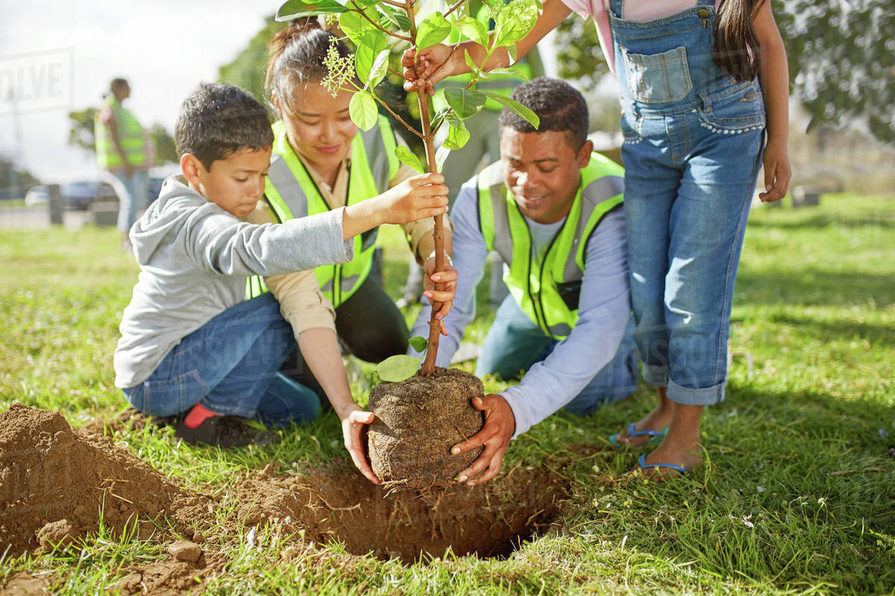](https://www.google.co.uk/url?sa=i&url=https%3A%2F%2Fdissolve.com%2Fstock-photo%2FFamily-volunteers-planting-tree-sunny-royalty-free-image%2F101-D985-71-621&psig=AOvVaw1zjHjoCFpfjFxYrn4-uLZx&ust=1601580721778000&source=images&cd=vfe&ved=0CAIQjRxqFwoTCLDD_KXPkewCFQAAAAAdAAAAABAe)





[](https://www.google.co.uk/url?sa=i&url=https%3A%2F%2Fnewsroom.uhc.com%2Fhealth%2F2019-06-17-playing-benefits.html&psig=AOvVaw1P6UV0RwxJyXhZ_kIocY61&ust=1601580886738000&source=images&cd=vfe&ved=0CAIQjRxqFwoTCKCAtfPPkewCFQAAAAAdAAAAABAU)

[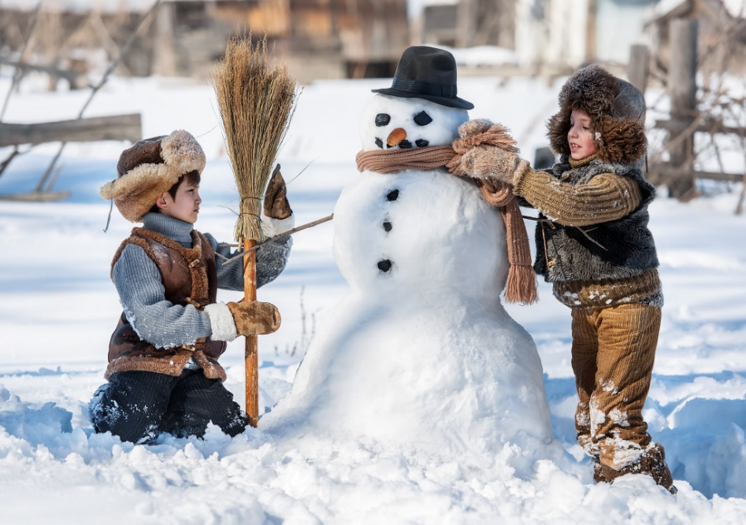](https://www.google.co.uk/url?sa=i&url=https%3A%2F%2Fthejigsawpuzzles.com%2FPuzzle-of-the-Day%2FBuilding-a-Snowman-jigsaw-puzzle&psig=AOvVaw3dfmJRRDTk-TSo1QMYImJ2&ust=1602009215003000&source=images&cd=vfe&ved=0CAIQjRxqFwoTCNjXiMeLnuwCFQAAAAAdAAAAABAD)

[](https://www.google.co.uk/url?sa=i&url=https%3A%2F%2Fwww.stocksy.com%2F1895342%2Fboys-washing-dishes--doing-some-chores&psig=AOvVaw2u4PaZet0j-BTJz1G2-Tnf&ust=1602009316102000&source=images&cd=vfe&ved=0CAIQjRxqFwoTCPim4_eLnuwCFQAAAAAdAAAAABAe)

[](https://www.google.co.uk/url?sa=i&url=https%3A%2F%2Fwww.manchestereveningnews.co.uk%2Fnews%2Fparenting%2Fparents-bedtime-stories-alexa-technology-16354988&psig=AOvVaw2HV5Esjz6n5lIuUe3j-7jl&ust=1602009528535000&source=images&cd=vfe&ved=0CAIQjRxqFwoTCKjGy9uMnuwCFQAAAAAdAAAAABAD)

[](https://www.google.co.uk/url?sa=i&url=https%3A%2F%2Fwww.telegraph.co.uk%2Ffood-and-drink%2Fequipment%2Fbaking-kit-to-encourage-children-into-the-kitchen%2F&psig=AOvVaw23CY_0Qmw5GafyI4SffOEA&ust=1602009592819000&source=images&cd=vfe&ved=0CAIQjRxqFwoTCIDmt4CNnuwCFQAAAAAdAAAAABAD)