**Adjectives Workshop**

**Activity 2**

Think of 3 different adjectives to describe each of the pictures below:

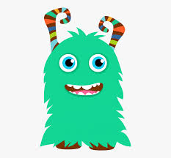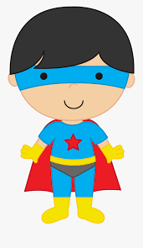

**Challenge - Adjectives Hunt!**

On you daily walk look for things that you could describe.

Is the wind cold? Are the trees tall? Is the dog fast? Is the shop busy?

Write it down and let me know!

**Activity 1**

**Be the teacher!** Add in adjectives to make my sentences more exciting:

|  |
| --- |
| 1. He is wearing a tie. |
| 1. They are jumping on the bed. |
| 1. She kicked the ball. |
| 1. I will go to the shop. |

What is an adjective?  
An adjective is a word used to describe a noun.

Some example of adjectives are:

|  |  |  |  |
| --- | --- | --- | --- |
| **Colours** | **Size** | **Texture** | **Feelings** |
| Red | Tiny | Rough | Excited |
| Brown | Huge | Pointy | Grumpy |
| Purple | Enormous | Bumpy | Happy |

We have complied some additional workshops to go through with your children. If you feel your child is confident with this concept then you are under no obligation to do so, we just feel that this may help consolidate their knowledge.