**Adjectives Workshop**

**Activity 2**

Think of 3 different adjectives to describe each of the pictures below:

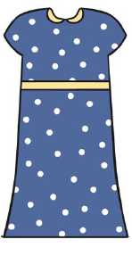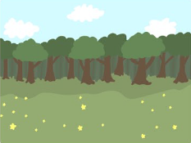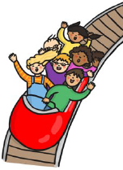

**Challenge - Adjectives Hunt!**

Search around your house for everything that you could describe.

Is your sofa green? Is your blanket soft? Is your fridge cold? Is your brother loud?

Write it down and let me know!

**Activity 1**

Can you help the wizard on his journey to give the king his birthday present? Watch this [video](https://www.youtube.com/watch?v=IT-G4c2-CHU) to help him learn about adjectives.

What is an adjective?  
An adjective is a word used to describe a noun.

Some example of adjectives are:

|  |  |  |  |
| --- | --- | --- | --- |
| **Colours** | **Size** | **Texture** | **Feelings** |
| Red | Tiny | Rough | Excited |
| Brown | Huge | Pointy | Grumpy |
| Purple | Enormous | Bumpy | Happy |

We have complied some additional workshops to go through with your children. If you feel your child is confident with this concept then you are under no obligation to do so, we just feel that this may help consolidate their knowledge.