Make an egg bounce.  You will need:  - A raw egg, White vinegar, a bowl, Golden syrup, Food dye, Kitchen roll, Scales.  https://www.youtube.com/watch?v=2ViGD-Ov5hQ&t=25s  Remember to send us in some videos of your bouncing eggs! | Science  Home Learning Choices – Summer 2 | Create a BFG potion, before you begin make a prediction! What do you think your potion will look like?  You will need:  - Washing up liquid, Bicarbonate of soda, Distilled malt vinegar, Glitter, Cabbage water.  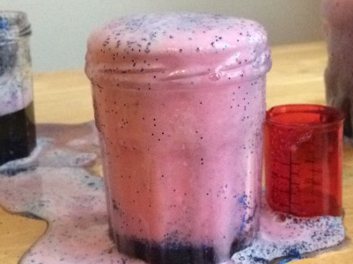  http://pearsandchocolatesauce.co.uk/2018/02/06/bfg-dream-potions/
Visit  https://www.bbc.co.uk/teach/terrific-scientific/KS2/zfj6bdm  to learn about plastic, motion and light! The resources focus on a series of practical investigations. For each investigation, there is a film which introduces the topic and demonstrates the investigation and a downloadable resource. | Grow a sunflower and keep a diary!  You will need:  - Sunflower seeds (or any other seeds), A pot, Soil.  Keep a sunflower diary and record any changes that you see.  Write what you think will happen to the seed and predict how tall your sunflower might get!  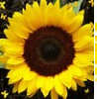  https://www.bbc.co.uk/teach/class-clips-video/science-ks1-ks2-ivys-plant-shop/zh2hkmn | Rainbow colour mixing!  You will need:  - A bowl, A cup of milk, Washing up liquid and food colouring.  Method:  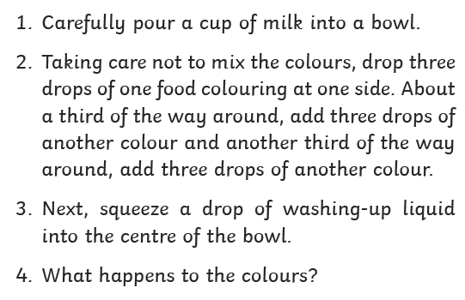
Paper towel colour mixing  You will need:  - A plastic cup, paper towels, water and food colouring.  Method:  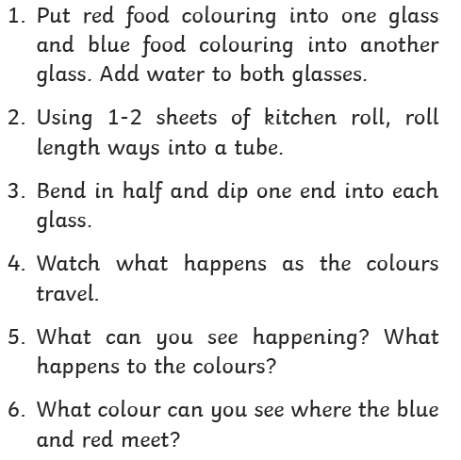  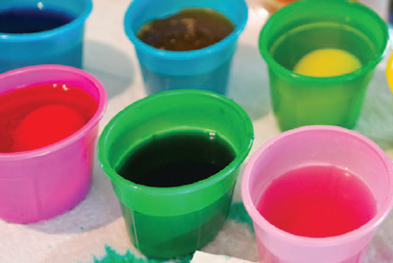  Try this next!  https://www.youtube.com/watch?v=fYniUL4l_BA | Make your own volcano  You will need:  - A plastic cup, vinegar, baking soda, water and food colouring preferably red.  Method:  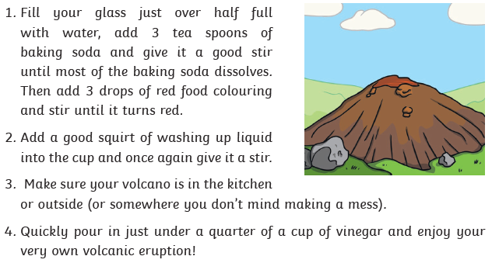  https://www.youtube.com/watch?v=wFSYLQkMR7U | Rain cloud in a jar.  You will need:  - A clear cup or jar, shaving cream, blue food colouring, water, pipette/ spoon and bowl.  Method:  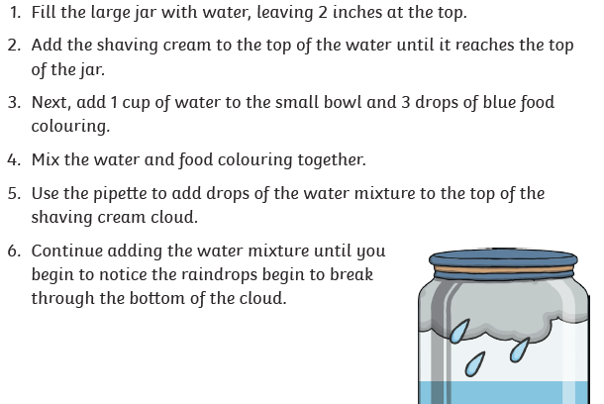  https://www.youtube.com/watch?v=hgBo6P0rjoM

