IALT: identify the parts of the plants  Can you draw and label all of the part of the plant on the following diagram? Write down the function of each part.  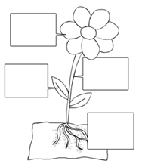 | IALT: explore questions.  https://mysteryscience.com/mini-lessons/sky-blue?code=e29713005027dc0893d54589b920ab7e  Why is the sky blue?  Write a prediction of why you may think this is.  Watch this video to help you find the answer.  Was your prediction (hypothesis) correct? | IALT: explore questions.  Why is the ocean salty?  What is your hypothesis (prediction)?  Look over this video to find out the answer:  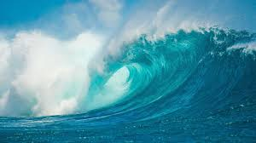  https://mysteryscience.com/mini-lessons/ocean-salt?code=cd7bda92c6bdf987cb3cda713ae69751#slide-id-5652
IALT: explore how hand sanitisers work.  https://mysteryscience.com/mini-lessons/germs-sanitizer?code=d1220d5754c6fab7c9de53d6654f41d6  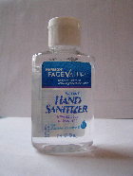  1. How does hand sanitiser kill germs?  2. What did this lesson make you curious about? What other questions do you have? | Science  Home Learning Choices – Summer 2 | IALT: design structures for purpose.  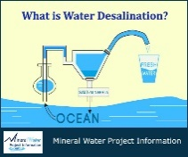  Imagine that you are on a boat in the middle of the ocean. There is salt water all around you, but you can’t drink it! Think like an inventor. What can you build so that you can get fresh water? (Hint: Think about what you just learned about salt water, rain, and fresh water.) Make a drawing of your invention.
IALT: set up an investigation.  Hand sanitiser is a good way to clean your hands when you can’t find a sink with soap and water. But how much water do you really need? What is the smallest amount of water you can use to wash your hands? One cup of water? A half-cup of water? One spoonful of water? Experiment in the bathroom and find out! | IALT: keep accurate recordings.  The sky isn’t always blue. You can keep a Sky Journal and write about the different colours of the sky. Draw the colour of the sky on different days. Draw the colour of the sky at different times of the day. How many colours can you find? Do you notice any patterns of when the sky changes colour? | IALT: set up an investigation.  Will salt help objects float?  Write down your hypothesis (prediction)  Set up three different glasses with the same amount of water. Have one glass as no salt, some salt, a lot of salt. Put an egg in each glass. What do you notice? Write down your observations. Was your prediction correct?

