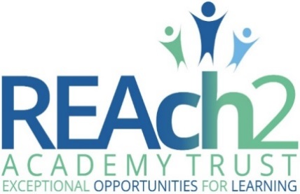

Accessibility plan
Civitas Academy

Audience: | Parents  School staff (in particular senior leaders, site management staff and inclusion staff)  Local Governing Bodies
Approved: | Headteacher – Date:
Other related policies: | equality, inclusion, health & safety, safeguarding
Policy owner: | Anna Thompson, Head of Governance & Policy
Policy model: | Principles: this means REAch2 schools can use this framework directly or maintain their own documentation, ensuring at the next opportunity that this aligns with REAch2 principles set out here
Review: | every 3 years or more frequently if national policy requirements or the school’s circumstances change
Version number: | 1.0 July 2017

REAch2 accessibility plan | 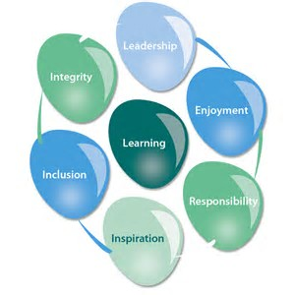

At REAch2, our actions and our intentions as school leaders are guided by our Touchstones:

Integrity | We recognise that we lead by example and if we want children to grow up to behave appropriately and with integrity then we must model this behaviour
Responsibility | We act judiciously with sensitivity and care. We don’t make excuses, but mindfully answer for actions and continually seek to make improvements
Inclusion | We acknowledge and celebrate that all people are different and can play a role in the REAch2 family whatever their background or learning style
Enjoyment | Providing learning that is relevant, motivating and engaging releases a child’s curiosity and fun, so that a task can be tackled and their goals achieved
Inspiration | Inspiration breathes life into our schools. Introducing children to influential experiences of people and place, motivates them to live their lives to the full
Learning | Children and adults will flourish in their learning and through learning discover a future that is worth pursuing
Leadership | REAch2 aspires for high quality leadership by seeking out talent, developing potential and spotting the possible in people as well as the actual
Contents

 | Page
POLICY OVERVIEW | 3
Overarching principles | 3
Intended impact | 3
Roles and responsibilities | 3
How this relates to national guidance and requirements | 3
Any key definitions | 3
IMPLEMENTATION | 4
ANNEXES
Accessibility Plan 2018 | 5

POLICY OVERVIEW

Overarching principles
- We are fully committed to REAch2 schools being as inclusive as possible, so that every child can reach their full potential.
- This applies to all settings in our schools – nursery as well as compulsory school age; mainstream as well as (where relevant) enhanced learning provision/specialist bases; core school time as well as before and after school care and activities.
- Accessibility plans for REAch2 schools should cover the three core areas (physical environment, curriculum and information) and anything else that is relevant, depending on the issues and circumstances for each school.
- We also aspire to our schools being as accessible as possible to all our parents/carers, staff and volunteers, whatever their needs and circumstances.
- We believe that everybody stands to gain where schools are inclusive, diverse and responsive to the needs of their local communities.

Intended impact
To help ensure that every REAch2 pupil has the best possible access to their schools’ facilities and resources.

Roles & responsibilities:
- Pupils and parents/carers will: alert the teacher or a senior leader if they are concerned about an issue of accessibility or have ideas about further improving inclusion
- REAch2 schools will: develop, maintain and keep under review a relevant and appropriate accessibility plan
- REAch2 central staff will: provide support to the school as necessary, particularly via the estates, education and safeguarding leads within the regional team
- REAch2 local governors will: provide scrutiny, support and challenge to the school’s senior leaders on the accessibility plan and its implementation

How this relates to national guidance & requirements
Schools need to carry out accessibility planning for disabled pupils under the Equality Act 2010. In particular, under paragraph 3 of Schedule 10 to the Act, schools must publish an accessibility plan, to include details of how they are:
- increasing your disabled pupils’ ability to participate in your school’s curriculum
- improving the physical environment of your school so disabled pupils can take better advantage of the education, benefits, facilities and services you offer
- improving the availability of accessible information to your disabled pupils
Our schools’ actions in relation to the public sector equality duty and equality objectives are also relevant here – see our separate Equalities Duty Framework document.

Any key definitions
Person with a disability – defined by section 6 of the Equality Act 2010 as if he or she has “a physical or mental impairment and the impairment has a substantial and long-term adverse effect on his or her ability to carry out normal day-to-day activities”.

Implementation

It is for the Headteacher to develop and approve the accessibility plan, working with senior leaders, relevant members of staff (such as the site manager or inclusion officer) and local governors.

REAch2 central staff can provide support and expertise, including the Regional Maintenance Surveyor (in relation to the physical environment) and the Regional Director or Associate School Leaders (in relation to curriculum and resources).

National guidance is that the accessibility plan can be a standalone document or part of another document such as the School Development Plan.

REAch2 schools should keep their progress against the plan under regular review (at least annual), drawing on the scrutiny and challenge of local governors. The objectives themselves should be reviewed every three years, or sooner if there have been changes in the circumstances of the school that affect accessibility in any of the three given dimensions (physical, curriculum, information).

The plan must be published on the school’s website and available in hard copy on request.

ACCESIBILITY PLAN 2018

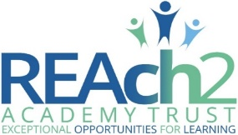

School name: Civitas Academy
Date plan was approved by the Headteacher: JANUARY 2018
Date of most recent review: JANUARY 2018

Objectives – specific, measurable | Expected actions/timeframes | Links to other key documents (if any) | Cost (if relevant) | Date achieved or progress review
PHYSICAL ENVIRONMENT
To be aware of the access needs of disabled children, staff, governors, parents and carers  To ensure the school staff and governors are aware of any access issues | To create access plans for individual disabled children.  To ensure parents, staff and governors can access areas of school used for meetings.  Staff to share relevant information to other staff members. | Equality Duties Framework  Inclusion Policy and Procedures |  | Ongoing
CURRICULUM
Review curriculum and assembly themes to ensure that disability issues are included | To make the school community aware that a disability is not a barrier to success. | Inclusion Policy and Procedures |  | Review in September 2018
Review P.E. to ensure that it is accessible for all pupils and that disability sports are also covered | All children participate in P.E.  Children have access to a breadth of different sports. | Inclusion Policy and Procedures |  | Review in September 2018

