Use your skill and imagination to finish this picture. | Visit: https://www.bbc.co.uk/bitesize/articles/zn4hpg8  Watch the videos on how you can become a historian.  Interview a member of your family about a significant event that they have experienced.  Remember to ask, who, how, what, why, where and when.  Use the skills you have learnt from the website to help you find out as much information as you can. | Watch this clip: https://www.bbc.co.uk/teach/class-clips-video/history-ks2-introducing-ancient-egypt/z6jrkmn  Make a poster comparing life in ancient Egypt to your life now.  What are the similarities and differences?
Visit: https://www.bbc.co.uk/bitesize/topics/zg87xnb/articles/z4wdnrd/  Learn about ancient Egyptian toys and games. Which game do you think you’d like best? How do the ancient Egyptian toys and games compare to the ones we have today?  Here you can have a go at making your own Mehen board:  https://bam.files.bbci.co.uk/bam/live/content/zdx4pg8/pdf#sa-link_location=blocks&intlink_from_url=https%3A%2F%2Fwww.bbc.co.uk%2Fbitesize%2Ftopics%2Fzg87xnb%2Farticles%2Fz4wdnrd%2F&intlink_ts=1589809353034-sa | History  Home Learning Choices – Summer 2 | Watch this virtual gallery tour: https://www.youtube.com/watch?v=9NTnSCiu1HQ:  Investigate two Egyptian artefacts.  When were they made?  What are they made from?  What were they used for?  Include any other information you find out about them.
Create a time capsule of your time during lockdown.  Watch this video: https://www.youtube.com/watch?v=1kgUs4UHVK8  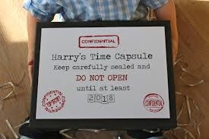  This video gives you some ideas of what you could include in your time capsule, these are just suggestions, you can put in anything you feel is special. | Visit: https://www.bbc.co.uk/bitesize/topics/zg87xnb/articles/zf4cxyc/  Watch the video about what happened to the ancient Egyptians. What has changed?  Further down the page you can explore more about the history of ancient Egypt by clicking on the interactive scroll. | Make a timeline of your life so far using photographs or drawings.  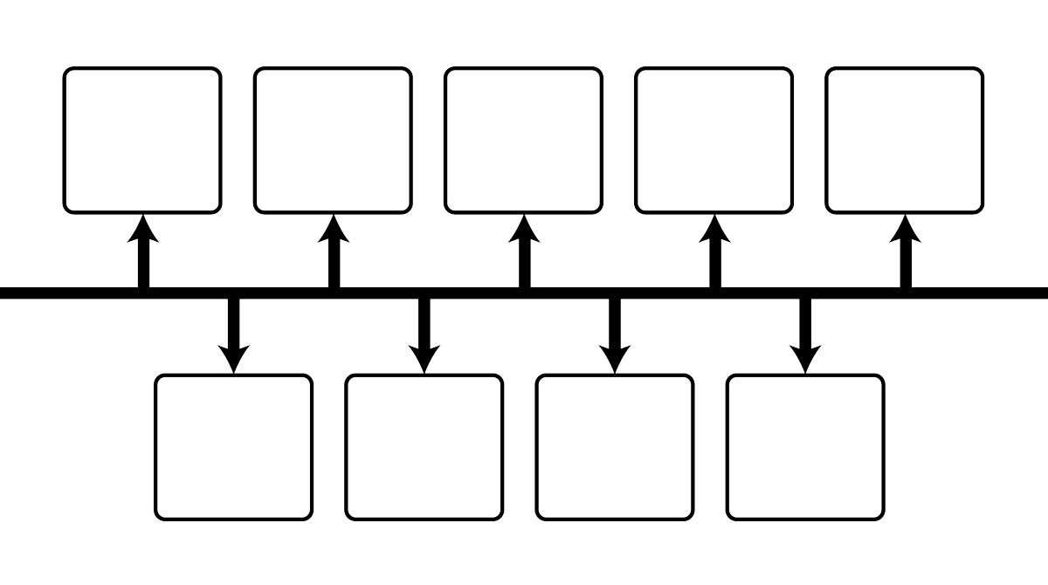  The time line should start at your birth, marking significant events up until the present day. Remember to include the date of each event on your timeline.

