Time zones  Watch this clip:  https://www.bbc.co.uk/bitesize/topics/zvsfr82/articles/zjk46v4  What are time zones?  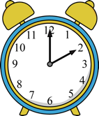  Write down the time in the UK now. Research what the time is now for Egypt and 3 other places of your choice. | 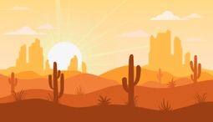  Desertification  Desertification happens when an area which is already dry becomes a desert. It causes land that people live on and farm becomes inhospitable. It is partly caused through the activity of humans.  Research how and why this is happening and create a poster to help stop desertification. | Earning a living: Fair trade  Create a leaflet or poster to encourage people to buy more Fairtrade items.  Include:  What is fair trade?  What kind of products do fair trade organisations trade?  How do you know if an item is fair trade?
Plants in extreme environments  Watch this clip:  https://www.bbc.co.uk/bitesize/clips/z69rkqt  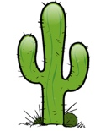  Draw your own cactus and label it with the features which allow it to survive and grow in the harsh desert environment. | Geography  Home Learning Choices – Summer 2 | Geographical features- comparing countries  What do you think the main differences are between Egypt and the United Kingdom?  Write a list of similarities and differences displaying these characteristics.  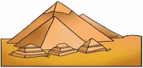  Challenge: Can you display these on a Venn Diagram?
The seven continents  Research the difference between a continent and a country. Create ‘top trump’ cards for the 7 continents of the world. On each card write their size, number of countries, population and 2 interesting facts.  Challenge: Which continents have you visited? Where would you find Egypt? | Plants around the world  Research which food is grown in the UK.  Investigate the produce grown in Egypt, how does this differ? Why do different countries grow different things?  Challenge: Look at your fruit, veg and other food items in your house. Where did they come from? | 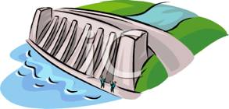  The River Nile: - The Aswan High Dam  During the time of the ancient Egyptians the River Nile flooded every year. The Aswan Dam was originally built in 1898 to stop the flooding. There were varied opinions on this dam by the locals.  https://connectusfund.org/17-pros-and-cons-of-aswan-high-dam  Use this website to help write a short formal letter to the Egyptian President telling him whether you think it should be kept or removed.

