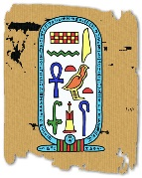  IALT: Create an Egyptian cartouche using homemade salt dough.  (A cartouche is an ancient Egyptian name plate. It is shaped like an oval with a horizontal bar at the bottom)  What you need: Plain flour, Table salt, Water, Measuring cups, Large mixing bowls, Paint and Paint brushes  Watch how to make salt dough here: https://www.youtube.com/watch?v=L7sH9bj-fl0  Shape your dough into a cartouche shape. Once the cartouches are sculpted and baked, they are ready to paint. Some ideas include: · Spell out your name using hieroglyphics, Paint a couple of Egyptian symbols that you like or Paint your initials in hieroglyphics. | IALT: Create my own Egyptian headdress  What you need: Card (different colours), Glue, Paint, Feathers, Pencils and images of hieroglyphics and symbols to refer to.  How to make your headdress:  - Cut a strip of cardboard long enough to go around your head. With the help of a friend, measure the size and stick it together.  - Now using paper, paint, feathers, pencils, and anything else you have at home decorate it to create an Egyptian inspired headdress.  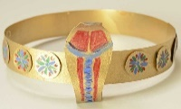  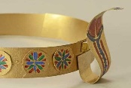 | 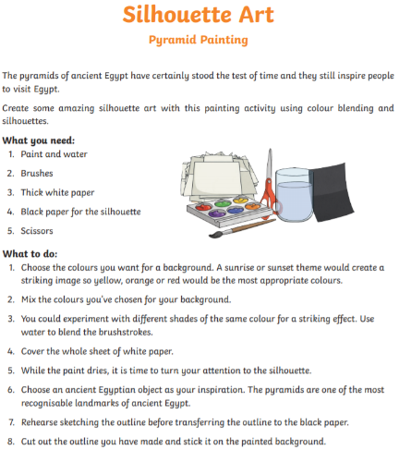  IALT: create silhouette art.
IALT: Create my own Egyptian pattern art.  What you need: Pencils, Charcoal (if you have it) and Paper.  Watch how to make rubbing art here: https://www.youtube.com/watch?v=1H4NflyzOvo  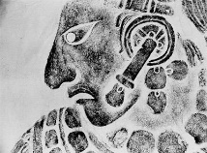  Can you create multiple rough pencil sketches/ charcoal rubbings of any patterns you can see in your surroundings (this activity can be carried out outside as well as inside). Focus on the details and shading within the pattern, rather than the colours you can see. Once you tried a few different patterns, choose/ combine your favourite patterns to create your ‘final piece’, using charcoal and pencil. Challenge: Try and create patterns inspired by your learning on the Egyptians. | Art  Home Learning Choices – Summer 2 | 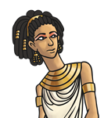  IALT: Create my own Egyptian jewellery using recycled objects.  Ancient Egyptians liked gold jewellery and wore a lot of it.  Can you design and make your own gold bands and collars?  - Use old plastic water bottles to create your cuffs. Cut out a ring then cover in foil or paint. Then, add details with beads for jewels or felt tip for patterns.  - Use card for a collar. Cut out the collar shape, measuring around your neck first. Then cover in foil or paint.
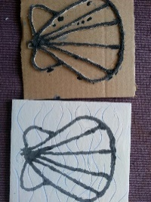  IALT: Create an Egyptian printed cloth.  What you need: Pencils, Paint, Paintbrush, String, PVA glue, Scissors, old piece of plain fabric and images of hieroglyphics and symbols for children to refer to.  How to print using string:  - Draw your shape (inspired by hieroglyphics and symbols) onto a small square of cardboard.  - Now, using string, carefully stick it down over the outline.  - Wait approximately 10 minutes for it to dry.  - Then paint on top of the string and print onto an old piece of fabric (old bedding sheet etc.) | IALT: Create my own Egyptian papyrus paper.  What you need: PVA glue, paper bag, recycled materials and colouring pencils/ paints.  How to make papyrus paper: https://www.crayola.com/crafts/egyptian-papyrus-paper-craft/  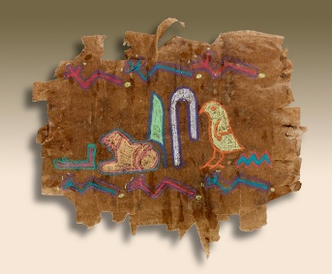 | IALT: Make a 3D pyramid using card.  Can you make a pyramid out of card? You may want to use sand mixed with paint to give it texture.  If your pyramid is big enough you could put your mummy and coffin inside of it.  You can use this link to make a 3D template of a pyramid: https://www.firstpalette.com/pdf/pyramid.pdf  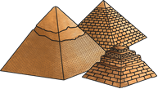  OR  You may want to challenge yourself and create your own pyramid shape and size!

